Practical 1

Storytelling and educational experience
Aim: Traditional educational materials often make complex topics like Artificial Intelligence difficult and less engaging for students. There is a need for an interactive digital learning experience that uses AI-generated visuals, a synthetic expert guide, realistic voice narration, and interactive questions to explain the advantages and disadvantages of AI in a simple and engaging way.

Objectives
- To explain the basic concept of Artificial Intelligence.
- To show the major advantages and disadvantages of AI.
- To create a hyper-realistic AI expert guide.
- To use AI-generated voice narration for storytelling.
- To create an interactive learning experience for students.

AI Tools Used
Tool | Purpose
Chat GPT | Script Generation
Gemini | AI character and scene image generation
Google AI Studio | Realistic voice-over generation
Canva/CapCut | Combining images, voice and presentation

AI Tool Used: Gemini Image Generation Purpose:
Gemini was used to create a hyper-realistic synthetic AI expert guide who acts as the main narrator and educator throughout the story.


Hyper-realistic synthetic AI expert guide
Character Design:
The character was designed as a young, professional AI expert with a consistent appearance, clothing, hairstyle, and visual style. The same character reference was used to maintain consistency across the different story scenes.

Story / Scenes

Scene 1 – Introduction to AI

Introduce AI and explain how it is used in everyday life.

Scene 2 – AI in Education

Show how AI provides personalized learning and helps students.

Scene 3 – AI in Healthcare
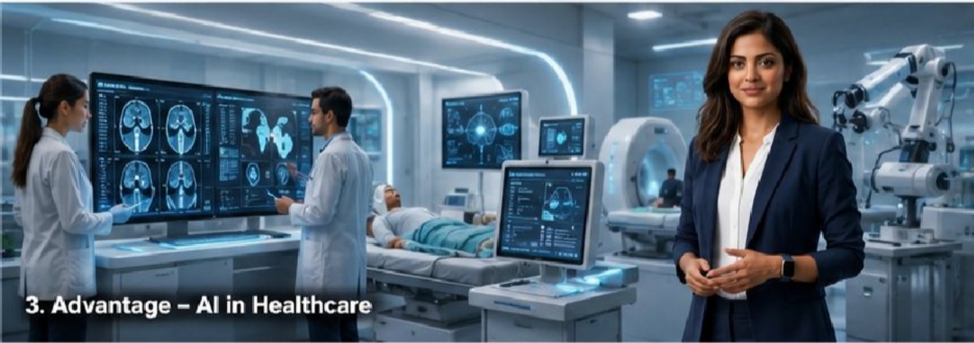
Explain how AI assists doctors with diagnosis and patient monitoring.

Scene 4 – Job Displacement

Explain how automation can replace some tasks while creating new types of jobs.

Scene 5 – Privacy, Bias and Ethics

Discuss privacy, biased algorithms, cybersecurity and responsible AI.

Scene 6 – Responsible AI

Explain why AI should be developed and used responsibly with human oversight.

Audio
Realistic AI voice narration was generated using Google AI Studio. The voice acts as the expert guide throughout the educational story.

Script Generated using Chat GPT
Scene 1 — What is Artificial Intelligence?
“Welcome to the world of Artificial Intelligence, or AI.
AI is a technology that allows computers and machines to perform tasks that usually require human intelligence, such as learning, recognizing images, understanding language, and solving problems.
From voice assistants and recommendation systems to self-driving technology and medical diagnosis, AI is already becoming part of our everyday lives.
But AI is not simply about making machines smarter. It also raises an important question: how can we use this powerful technology responsibly?”

Scene 2 — Advantage: AI in Education
“AI is changing the way students learn and teachers teach.
Instead of giving every student exactly the same learning experience, AI can analyze a student's progress and provide personalized lessons, explanations, exercises, and feedback.
For example, an AI tutor can explain a difficult concept in different ways until the student understands it.
This can make education more personalized, accessible, and efficient while allowing students to learn at their own pace.”

Scene 3 — Advantage: AI in Healthcare
“Another important advantage of AI can be seen in healthcare.
AI systems can analyze medical images, identify patterns in large amounts of health data, monitor patients, and help doctors make faster and more informed decisions.
For example, AI can assist doctors in detecting signs of certain diseases that might be difficult to notice quickly.

However, AI should support healthcare professionals rather than completely replace human judgment, experience, and compassion.”

Scene 4 — Disadvantage: Jobs and Automation
“Although AI can improve productivity, it can also create challenges for workers.
Machines and AI systems can automate repetitive tasks that were previously performed by people, which may reduce the demand for certain jobs.
At the same time, AI is creating new careers in areas such as data science, robotics, AI development, and cybersecurity.
This means the future of work may require people to continuously learn new skills and adapt to changing technology.”

Scene 5 — Disadvantages: Privacy, Bias and Ethics
“AI can process enormous amounts of information, but this creates important ethical concerns.
Personal data can be collected and analyzed by AI systems, raising questions about privacy and how that information is being used.
AI can also produce biased results when the data used to train it contains human biases or does not represent everyone fairly.
That is why AI systems need transparency, strong security, human oversight, and ethical guidelines to ensure that technology is used fairly and responsibly.”

Scene 6 — Conclusion: Responsible AI
“Artificial Intelligence has the potential to transform education, healthcare, science, business, and everyday life.
At the same time, it can create challenges involving employment, privacy, security, bias, and ethical decision-making.
So, the question is not simply whether AI is good or bad. The real question is how we choose to develop and use it.
If humans combine innovation with responsibility, AI can become a powerful tool for solving problems and improving our future.

Now it's your turn: Would you trust AI to make important decisions that affect your life? Why or why not?”

Text to speech Using Google AI Studio :

Link: Text to speech for each scene

Final Video :
Link: AI generated Video

Requirement Mapping
Assignment Requirement | My Implementation
Storytelling & educational | AI Advantages and Disadvantages

experience | digital story
Synthetic expert guide | Gemini-generated AI expert
Consistent world assets | Consistent futuristic AI environments
Realistic voice-over | Google AI Studio
Educational purpose | Explains benefits, risks and responsible AI

Conclusion
Artificial Intelligence provides significant opportunities in education, healthcare, productivity, research, and everyday life. However, it also introduces challenges related to employment, privacy, bias, cybersecurity, and ethical decision-making.
This project demonstrates how generative AI can be used to transform a traditional educational topic into an engaging storytelling experience. By combining a synthetic expert character, AI-generated visuals, realistic voice narration, and interactive questioning, the project makes learning about AI more immersive and engaging.
The main message of the project is that AI is neither completely good nor completely bad. Its impact depends on how responsibly humans design, develop, and use the technology.

Practical : 2
Multimodal Text and Foundation Model Benchmarking AIM: To explore and compare web-based Generative AI tools for text generation, multimodal understanding, and image generation using different prompts.

Tools Required
- Google AI Studio / Gemini
- Craiyon

PART A
Google AI Studio / Gemini
Step 1 — Open Google AI Studio Step 2 — Start a new prompt
Step 3 — Enter a simple text prompt
Explain the difference between monolithic architecture and microservices architecture.
Compare them based on:
- Scalability
- Deployment
- Maintenance
- Fault isolation
- Complexity

Step 4 — Run the prompt
Step 5 — Observe the response
The model correctly understood the comparison requested. if that matches your actual observation.
It provide all five requested points:
Scalability → Yes Deployment → Yes Maintenance → Yes Fault isolation → Yes Complexity → Yes

Step 6 — Measure response time
Start a stopwatch immediately before running the prompt. Response time = 12.11 seconds

Step 7 — Take Screenshot

Parameter | Observation
AI Platform | Google AI Studio
Model | Gemini 3 Flash Preview
Thinking Level | High
Input Tokens | 66
Output Tokens | 1,638
Total Tokens | 1,704
Estimated Input Cost | $0.000033
Estimated Output Cost | $0.004914
Estimated Total Cost | $0.004947
Response | Generated successfully
Response Time | 12.11 seconds

PART B

Multimodal Experiment
This is important because Experiment 1 is about multimodal AI. Multimodal means that the AI works with more than one type of input, such as: Text + Image

Step 8 — Find an image
Use a simple architecture diagram.

Step 9 — Upload the image
In Google AI Studio:

Step 10 — Enter this prompt
Analyze the uploaded architecture diagram.
- Identify the major components.
- Explain the role of each component.
- Explain the data flow.
- Identify possible bottlenecks.
- Suggest two improvements.

Step 11 — Generate the response : Run the prompt.

Step 12 — Check image understanding
Image recognized, Yes Components identified, Yes Data flow explained, Yes Bottlenecks identified, Yes Improvements suggested, Yes

PART C
Craiyon: Now perform image generation.
Step 13 — Open Craiyon
Step 14 — Enter an image-generation prompt
A futuristic AI-powered university campus with smart classrooms, autonomous robots, renewable energy systems, students using AI assistants, futuristic technology, detailed digital art.

Step 15 — Generate
Click the button used to generate the images.

Step 16 — Observation
The AI successfully understood the prompt and generated a futuristic AI-powered university campus containing smart classrooms, autonomous robots, AI technology, students, and renewable-energy systems. The visual quality is Excellent.

Step 17 — Screenshot
OBSERVATION: The experiment successfully demonstrated the use of web-based Generative AI tools for text generation, multimodal image understanding and text-to-image generation. Google AI Studio/Gemini was used for text and image-based prompting, while Craiyon was used for image generation.

EXPERIMENT 2

Speech Synthesis and Audio Conversion Pipelines
AIM: The source document identifies Google Voice Typing, Google AI Studio TTS and Google Translate as the web-based tools for this experiment.

PART A
Google Voice Typing Step 1: Open Google Docs.
Step 2: Open: Tools then Voice typing
Step 3: Allow microphone access if your browser asks. Step 4 — Prepare the passage
Artificial intelligence and deep learning are transforming modern software applications. Convolutional neural networks are commonly used for image classification, while transformer architectures are widely used in natural language processing.
Large language models can understand and generate human-like text.

Step 5 — Start voice typing
Click the microphone. Speak the complete passage clearly.Try to maintain a normal speaking speed.

Step 6 — Stop recording
Read the generated text. Compare it with the original.

Step 7 — Identify errors
There are three major error types. Substitution
Original: model Recognized: modal Deletion
Original: deep learning is powerful Recognized: deep learning powerful

Insertion
Original: deep learning is powerful Recognized: deep learning is very powerful

Step 8 — Calculate WER
The formula from your PDF is:
WER = (S+D+I)/N
where:
S = substitutions D = deletions
I = insertions
N = total words spoken. Substitutions (S) = 0 Deletions (D) = 0 Insertions (I) = 0
Total reference words (N) = 38 WER = (S + D + I) / N × 100
= (0 + 0 + 0) / 38 × 100
= 0 / 38 × 100
WER = 0%

PART B

Google AI Studio TTS Step 9: Open Google AI Studio again.
Step 10
Open the relevant TTS/audio-generation functionality available in your account/interface.

Step 11 — Enter text

Welcome to the Generative AI Laboratory. Today we are evaluating speech synthesis.
Artificial intelligence is transforming modern technology.
Step 12: Generate the speech.

Step 13: Listen
Listen carefully.

Step 14 — Screenshot

PART C
Google Translate
Step 15: Open Google Translate
Step 16 Select: From: English To: Hindi Step 17 Enter:
Artificial intelligence is transforming healthcare, education and software development.
Artificial Intelligence Machine Learning Deep Learning Neural Network
Convolutional Neural Network Natural Language Processing Large Language Model Transformer Architecture Observe how they are translated.
Step 18: Click/allow the translation to happen.

Step 19 — Check the result

Observations:
Result: The experiment successfully demonstrated web-based speech recognition, speech synthesis and translation. Google Voice Typing was used to convert speech into text, Google AI Studio was used for speech synthesis, and Google Translate was used for language translation.

EXPERIMENT 3
Computer Vision and Classification Workflows Aim: To explore browser-based computer vision and image classification using Google Teachable Machine and Quick, Draw!.

PART A — Google Teachable Machine
I have added three classes with images

Class | Number of Images
Mammals | 12
Reptiles | 11
Birds | 10
Total | 33

Training the model:

Training Parameter | Value
Epochs | 50
Batch Size | 16
Learning Rate | 0.01

Here i have uploaded an image of a turtle showing 87% mammals .
Conclusion:
The experiment demonstrated that an image classification model can be developed without writing machine-learning code. Teachable Machine provides a simple workflow in which images can be collected, grouped into classes, used for model training, tested with new images and exported for further use.

PART B — Quick, Draw!
Step 1
Search:

Google Quick, Draw!
Open the official Quick, Draw! Website.

Step 2
Start the drawing game.

Step 3
The system gives you an object to draw.

Step 4
Draw the object using your mouse/trackpad.

Step 5
Observe how quickly the AI guesses your drawing.

Step 6
Repeat for 5–10 drawings.

Observation:
Two browser-based computer vision tools were explored. Google Teachable Machine was used to train and test an image-classification model, while Quick, Draw! was used to observe real-time recognition of hand-drawn objects.

EXPERIMENT 4

Ethical AI Assessment

PART A — The Moral Machine
Aim: To study ethical decision-making and identify ethical factors involved in AI-based autonomous decision scenarios.
Took a 13-question based on whom to save and whom to kill in a playground type scenario and after evaluating my answers moral machine generated my report.
Here is the link to the results: results

Observation:
The Moral Machine scenarios demonstrated that autonomous AI systems may encounter situations where different ethical principles lead to different decisions. The aggregate results can be interpreted in terms of principles such as utilitarian decision-making, protective preferences and social-status-related preferences.

Practical: 2

Generative AI Tools Exploration and Comparison WEB-BASED AI TOOLS ONLY

EXPERIMENT 1
Multimodal Text and Foundation Model Benchmarking AIM: To explore and compare web-based Generative AI tools for text generation, multimodal understanding, and image generation using different prompts.

Tools Required
- Google AI Studio / Gemini
- Craiyon

PART A
Google AI Studio / Gemini
Step 1 — Open Google AI Studio Step 2 — Start a new prompt
Step 3 — Enter a simple text prompt
Explain the difference between monolithic architecture and microservices architecture.
Compare them based on:
- Scalability
- Deployment
- Maintenance
- Fault isolation
- Complexity

Step 4 — Run the prompt
Step 5 — Observe the response
The model correctly understood the comparison requested. if that matches your actual observation.
It provide all five requested points: Scalability → Yes
Deployment → Yes Maintenance → Yes

Fault isolation → Yes Complexity → Yes

Step 6 — Measure response time
Start a stopwatch immediately before running the prompt. Response time = 12.11 seconds


Step 7 — Take Screenshot

Parameter | Observation
AI Platform | Google AI Studio
Model | Gemini 3 Flash Preview
Thinking Level | High
Input Tokens | 66
Output Tokens | 1,638
Total Tokens | 1,704
Estimated Input Cost | $0.000033
Estimated Output Cost | $0.004914
Estimated Total Cost | $0.004947
Response | Generated successfully
Response Time | 12.11 seconds

PART B

Multimodal Experiment
This is important because Experiment 1 is about multimodal AI. Multimodal means that the AI works with more than one type of input, such as: Text + Image

Step 8 — Find an image
Use a simple architecture diagram.
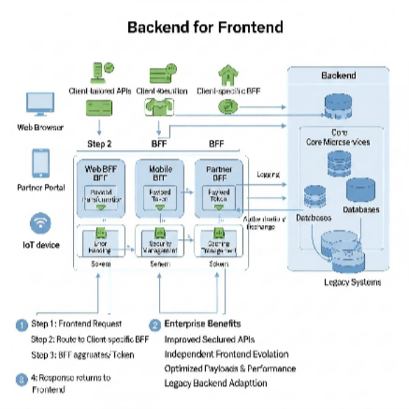

Step 9 — Upload the image
In Google AI Studio:

Step 10 — Enter this prompt
Analyze the uploaded architecture diagram.
- Identify the major components.
- Explain the role of each component.
- Explain the data flow.
- Identify possible bottlenecks.
- Suggest two improvements.

Step 11 — Generate the response : Run the prompt.
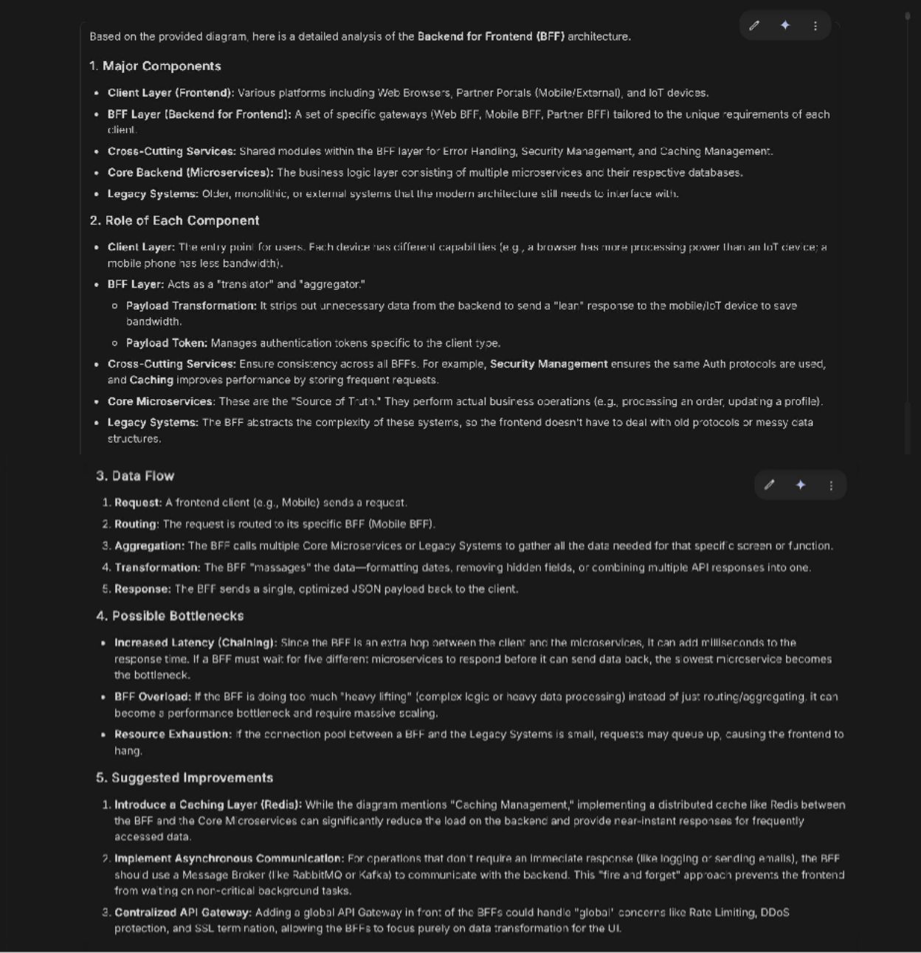

Step 12 — Check image understanding
Image recognized, Yes Components identified, Yes Data flow explained, Yes Bottlenecks identified, Yes Improvements suggested, Yes

PART C
Craiyon: Now perform image generation.
Step 13 — Open Craiyon

Step 14 — Enter an image-generation prompt
A futuristic AI-powered university campus with smart classrooms, autonomous robots, renewable energy systems, students using AI assistants, futuristic technology, detailed digital art.

Step 15 — Generate
Click the button used to generate the images.

Step 16 — Observation
The AI successfully understood the prompt and generated a futuristic AI-powered university campus containing smart classrooms, autonomous robots, AI technology, students, and renewable-energy systems. The visual quality is Excellent.

Step 17 — Screenshot

OBSERVATION: The experiment successfully demonstrated the use of web-based Generative AI tools for text generation, multimodal image understanding and text-to-image generation. Google AI Studio/Gemini was used for text and image-based prompting, while Craiyon was used for image generation.

EXPERIMENT 2

Speech Synthesis and Audio Conversion Pipelines
AIM: The source document identifies Google Voice Typing, Google AI Studio TTS and Google Translate as the web-based tools for this experiment.

PART A
Google Voice Typing Step 1: Open Google Docs.
Step 2: Open: Tools then Voice typing
Step 3: Allow microphone access if your browser asks. Step 4 — Prepare the passage
Artificial intelligence and deep learning are transforming modern software applications. Convolutional neural networks are commonly used for image classification, while transformer architectures are widely used in natural language processing.
Large language models can understand and generate human-like text.

Step 5 — Start voice typing
Click the microphone. Speak the complete passage clearly.Try to maintain a normal speaking speed.

Step 6 — Stop recording
Read the generated text. Compare it with the original.


Step 7 — Identify errors
There are three major error types. Substitution
Original: model Recognized: modal Deletion
Original: deep learning is powerful Recognized: deep learning powerful Insertion
Original: deep learning is powerful Recognized: deep learning is very powerful

Step 8 — Calculate WER
The formula from your PDF is:
WER = (S+D+I)/N
where:
S = substitutions D = deletions
I = insertions
N = total words spoken. Substitutions (S) = 0 Deletions (D) = 0 Insertions (I) = 0
Total reference words (N) = 38 WER = (S + D + I) / N × 100
= (0 + 0 + 0) / 38 × 100
= 0 / 38 × 100
WER = 0%

PART B

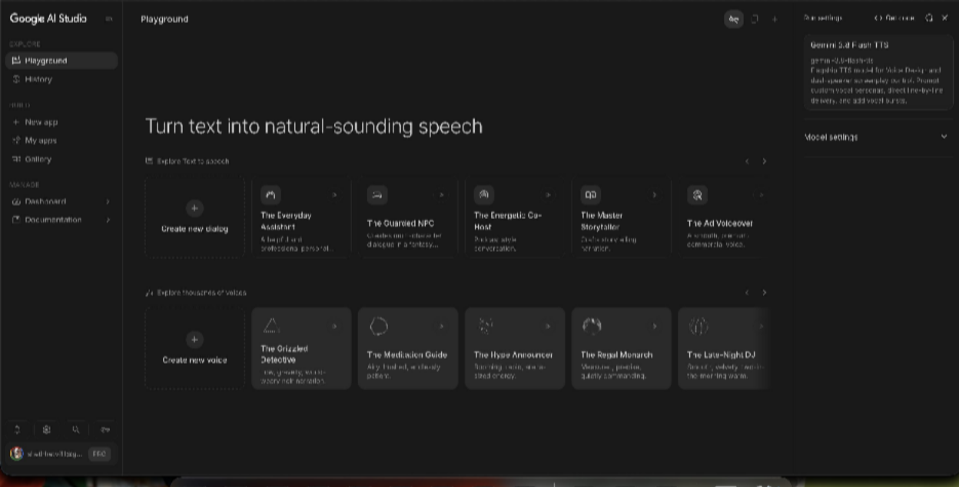
Google AI Studio TTS Step 9: Open Google AI Studio again.

Step 10
Open the relevant TTS/audio-generation functionality available in your account/interface.

Step 11 — Enter text
Welcome to the Generative AI Laboratory. Today we are evaluating speech synthesis.
Artificial intelligence is transforming modern technology.
Step 12: Generate the speech.

Step 13: Listen
Listen carefully.

Step 14 — Screenshot

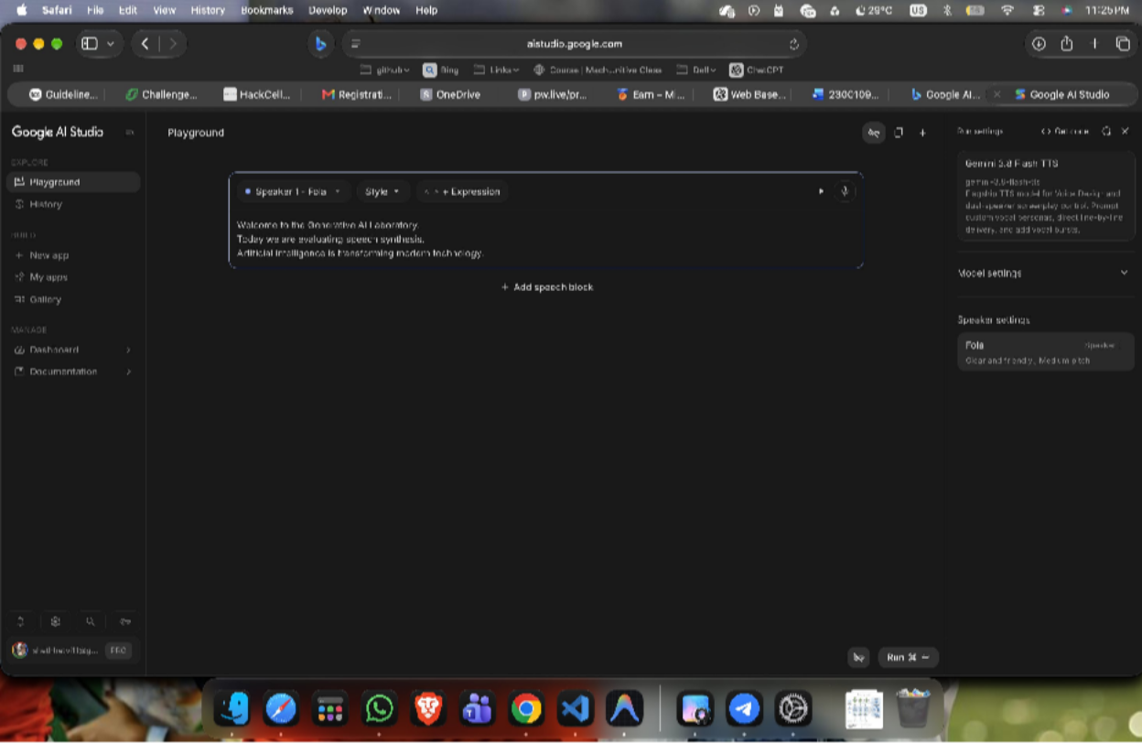

PART C
Google Translate

Step 15: Open Google Translate
Step 16 Select: From: English To: Hindi Step 17 Enter:
Artificial intelligence is transforming healthcare, education and software development.
Artificial Intelligence Machine Learning Deep Learning Neural Network
Convolutional Neural Network Natural Language Processing Large Language Model Transformer Architecture Observe how they are translated.

Step 18: Click/allow the translation to happen. Step 19 — Check the result


Observations:
Result: The experiment successfully demonstrated web-based speech recognition, speech synthesis and translation. Google Voice Typing was used to convert speech into text, Google AI Studio was used for speech synthesis, and Google Translate was used for language translation.

EXPERIMENT 3
Computer Vision and Classification Workflows Aim: To explore browser-based computer vision and image classification using Google Teachable Machine and Quick, Draw!.

PART A — Google Teachable Machine
I have added three classes with images

Class | Number of Images
Mammals | 12
Reptiles | 11
Birds | 10
Total | 33



Training the model:

Training Parameter | Value
Epochs | 50
Batch Size | 16
Learning Rate | 0.001


Here i have uploaded an image of a turtle showing 87% mammals .

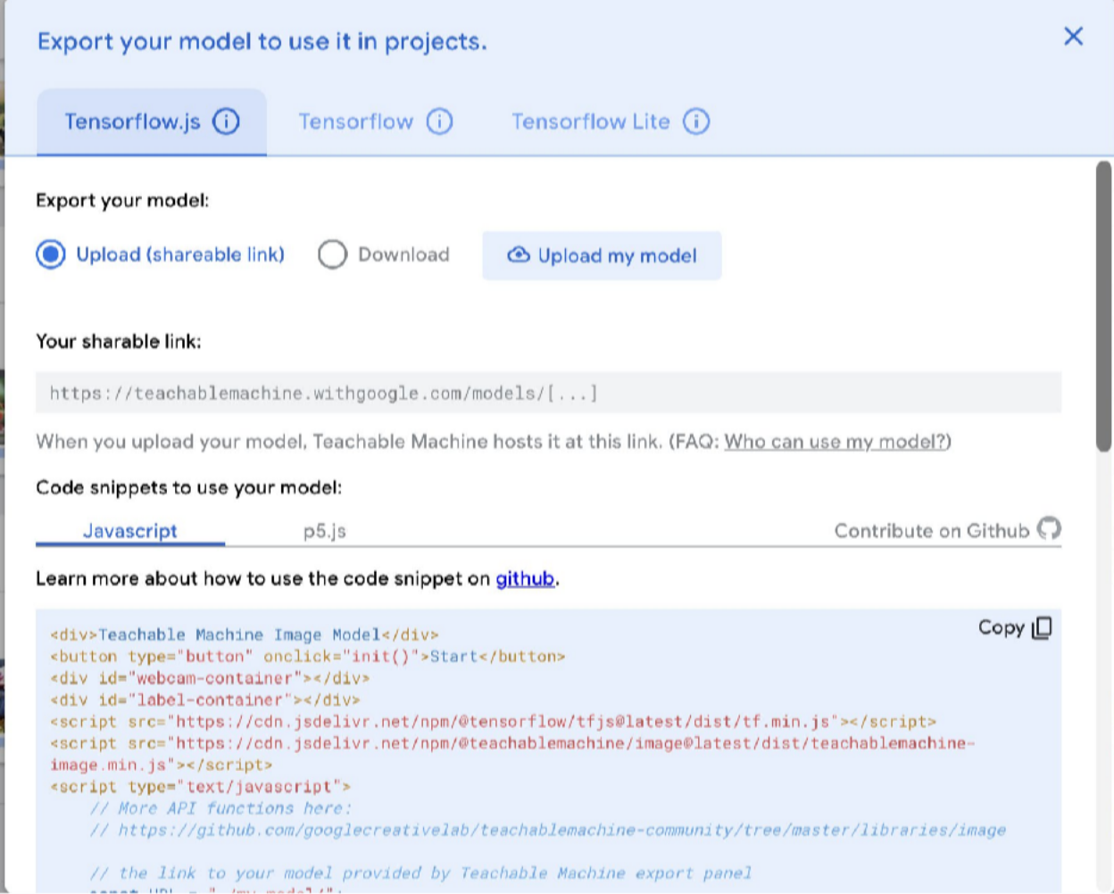
Conclusion:
The experiment demonstrated that an image classification model can be developed without writing machine-learning code. Teachable Machine provides a simple workflow in which images can be collected, grouped into classes, used for model training, tested with new images and exported for further use.

PART B — Quick, Draw!
Step 1
Search:

Google Quick, Draw!
Open the official Quick, Draw! Website.
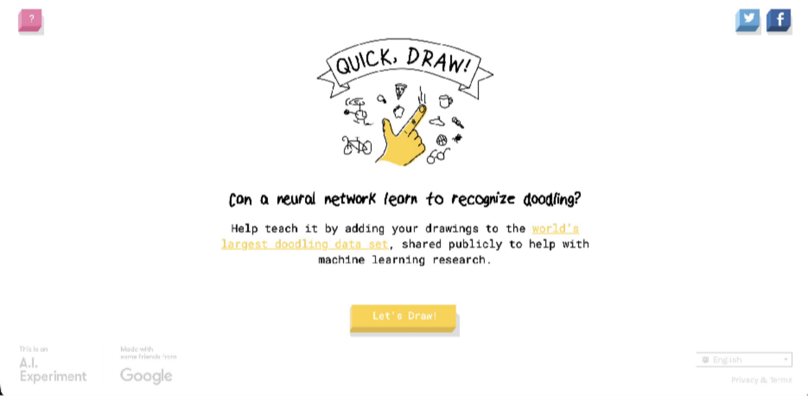

Step 2
Start the drawing game.


Step 3
The system gives you an object to draw.

Step 4
Draw the object using your mouse/trackpad.

Step 5
Observe how quickly the AI guesses your drawing.

Step 6
Repeat for 5–10 drawings.
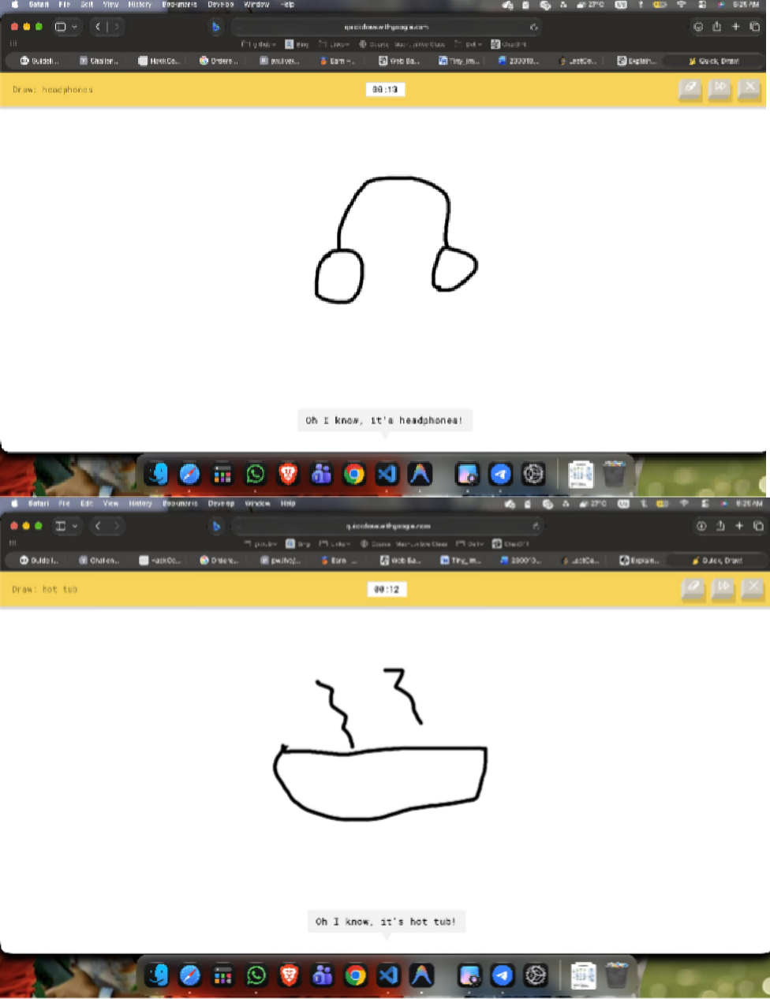

Observation:

Two browser-based computer vision tools were explored. Google Teachable Machine was used to train and test an image-classification model, while Quick, Draw! was used to observe real-time recognition of hand-drawn objects.

EXPERIMENT 4

Ethical AI Assessment

PART A — The Moral Machine
Aim: To study ethical decision-making and identify ethical factors involved in AI-based autonomous decision scenarios.
Took a 13-question based on whom to save and whom to kill in a playground type scenario and after evaluating my answers moral machine generated my report.
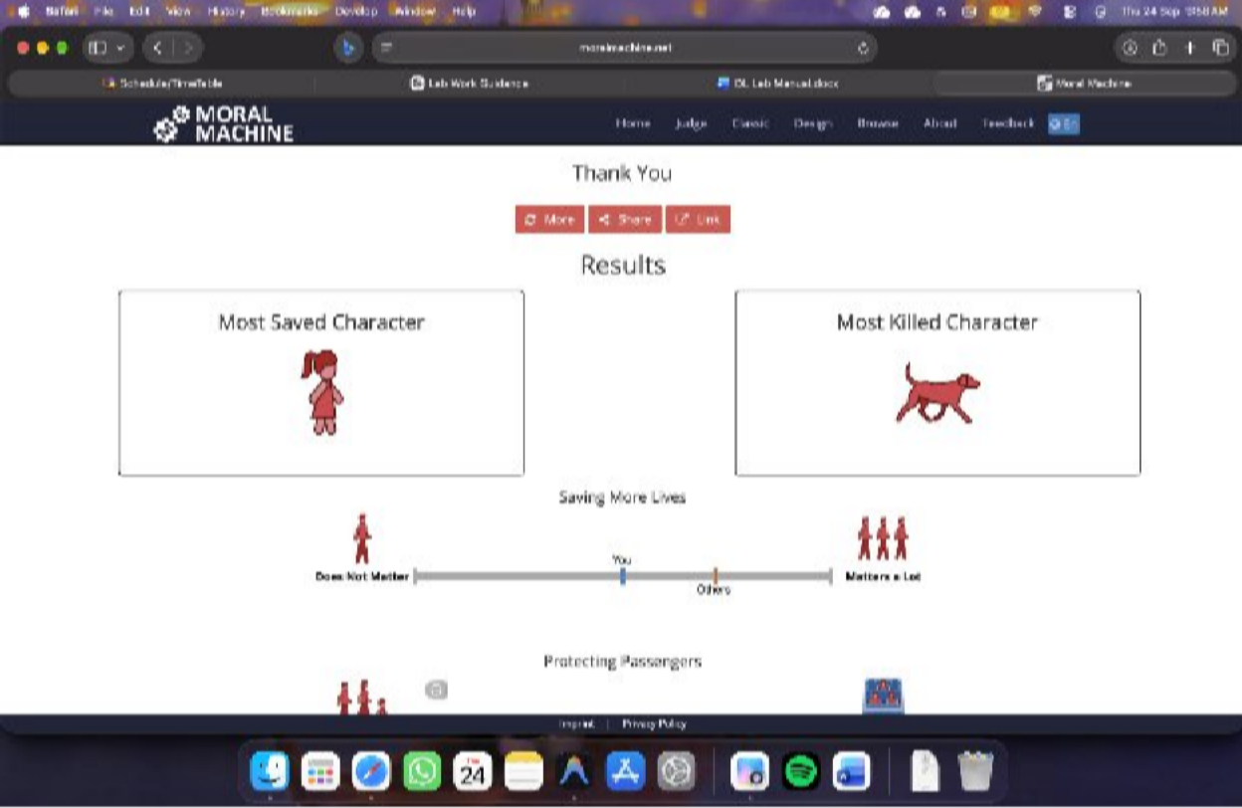
Here is the link to the results: results

Observation:
The Moral Machine scenarios demonstrated that autonomous AI systems may encounter situations where different ethical principles lead to different decisions. The aggregate results can be interpreted in terms of principles such as utilitarian decision-making, protective preferences and social-status-related preferences.

Deep Learning Laboratory - Experiment 3

Aim: To implement core deep learning activation functions and loss functions using Python and NumPy without deep learning frameworks, and to evaluate their mathematical behavior through visualization and numerical tests.

Code:
import numpy as np
import matplotlib.pyplot as plt # Activation Function
def sigmoid(x):
return 1 / (1 + np.exp(-x)) def tanh(x):
return (np.exp(x) - np.exp(-x)) / (np.exp(x) + np.exp(-x)) def relu(x):
return np.maximum(0, x)
def leaky_relu(x, alpha=0.01):
return np.maximum(alpha * x, x) # Loss function
def mean_squared_error(y_true, y_pred): return np.mean((y_true - y_pred) ** 2) def binary_cross_entropy(y_true, y_pred): epsilon = 1e-15
y_pred = np.clip(y_pred, epsilon, 1 - epsilon) return -np.mean(
y_true * np.log(y_pred) +
(1 - y_true) * np.log(1 - y_pred)
)
if name == " main ": # Activation Functions
x = np.linspace(-10, 10, 200) sigmoid_output = sigmoid(x) tanh_output = tanh(x) relu_output = relu(x)
leaky_relu_output = leaky_relu(x)

activation_plots = { "Sigmoid": sigmoid_output, "Tanh": tanh_output, "ReLU": relu_output,
"Leaky ReLU": leaky_relu_output,
}
for name, values in activation_plots.items(): plt.figure(figsize=(6, 4))
plt.plot(x, values, color="blue") plt.xlabel("Input (x)") plt.ylabel("Output")
plt.title(f"{name} Activation Function") plt.grid(True)
plt.tight_layout() plt.show()
# MSE
y_true_reg = np.array([10.0, 20.0, 30.0])
y_pred_reg1 = np.array([11.0, 19.0, 31.0])
y_pred_reg2 = np.array([15.0, 20.0, 25.0])

mse1 = mean_squared_error(y_true_reg, y_pred_reg1) mse2 = mean_squared_error(y_true_reg, y_pred_reg2)

print("MSE Prediction 1:", f"{mse1:.4f}")
print("MSE Prediction 2:", f"{mse2:.4f}")

plt.figure(figsize=(6, 4))
plt.bar(["Prediction 1", "Prediction 2"], [mse1, mse2], color=["steelblue", "orange"])
plt.ylabel("MSE") plt.title("Mean Squared Error")
plt.ylim(0, max(mse1, mse2) * 1.5 + 1) plt.grid(axis="y", linestyle="--", alpha=0.5) plt.tight_layout()
plt.show()

# BCE
y_true_cls = np.array([1, 0, 1, 0])

y_pred_cls1 = np.array([0.9, 0.1, 0.8, 0.2])
y_pred_cls2 = np.array([0.1, 0.9, 0.2, 0.8])

bce1 = binary_cross_entropy(y_true_cls, y_pred_cls1) bce2 = binary_cross_entropy(y_true_cls, y_pred_cls2)

print("BCE (Confident & Correct):", f"{bce1:.4f}") print("BCE (Confident & Incorrect):", f"{bce2:.4f}")

plt.figure(figsize=(6, 4))
plt.bar(["Confident & Correct", "Confident & Incorrect"], [bce1, bce2], color=["green", "red"])
plt.ylabel("BCE") plt.title("Binary Cross Entropy")
plt.ylim(0, max(bce1, bce2) * 1.5 + 0.2) plt.grid(axis="y", linestyle="--", alpha=0.5) plt.tight_layout()
plt.show()

OUTPUT:
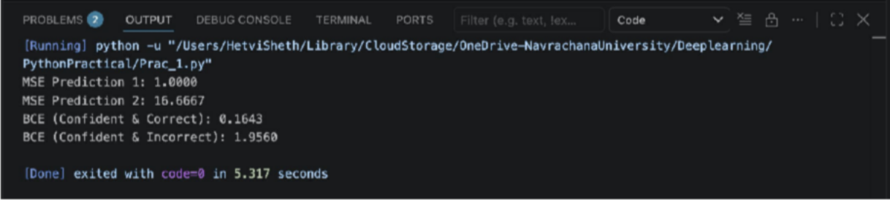

Graphs:
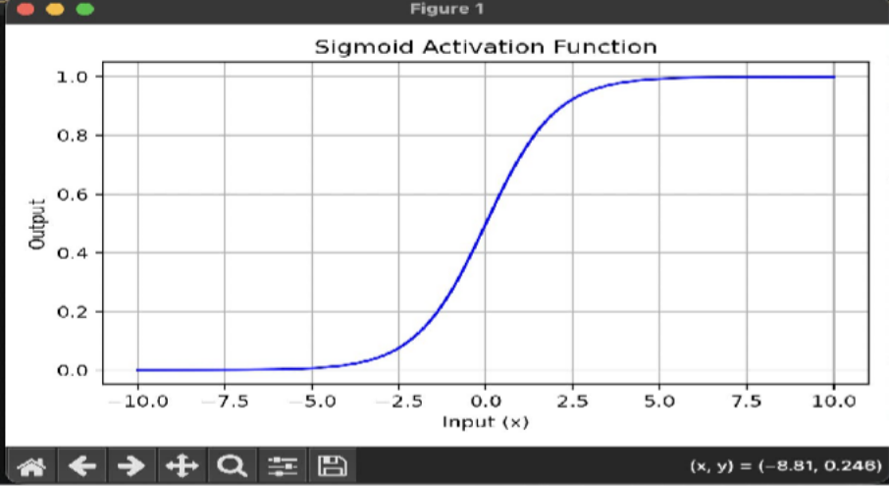
The Sigmoid function produces an S-shaped curve with output values between 0 and 1. At x=0, its output is 0.5. For very negative inputs, the output approaches 0, while for very positive inputs, it approaches 1.
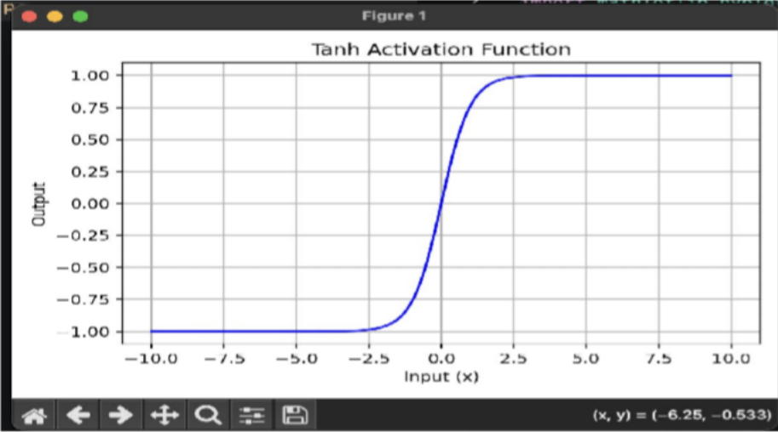
The Tanh function produces an S-shaped curve with output values between -1 and 1. At x=0, the output is 0. It approaches -1 for large negative inputs and 1 for large positive inputs.

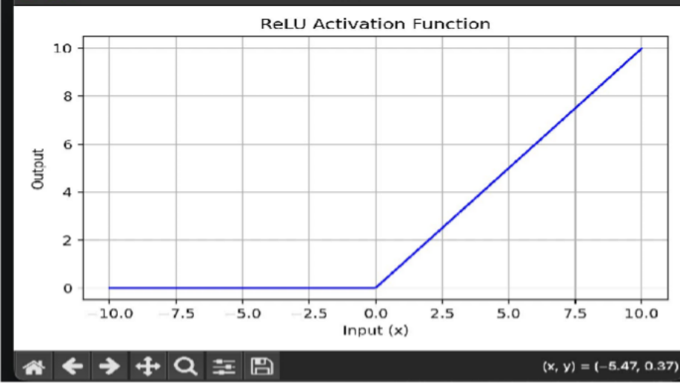
The ReLU function outputs 0 for negative inputs and increases linearly for positive inputs. It is simple and computationally efficient.
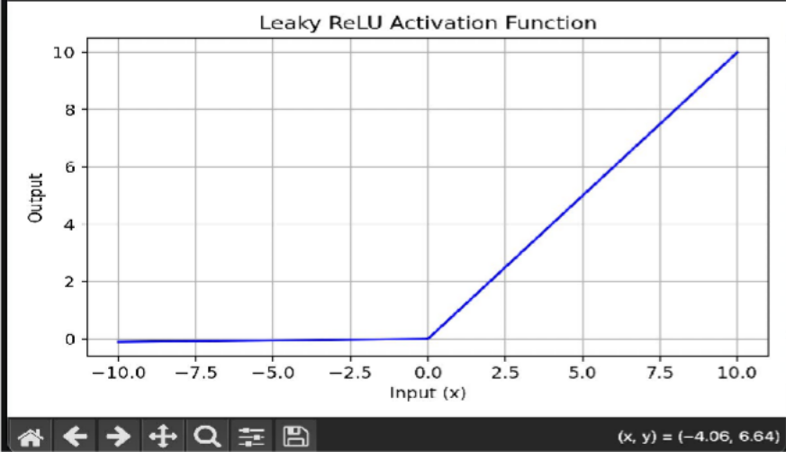
Leaky ReLU is similar to ReLU, but it allows a small negative output for negative inputs instead of becoming zero. In this experiment, the negative slope is 0.01.

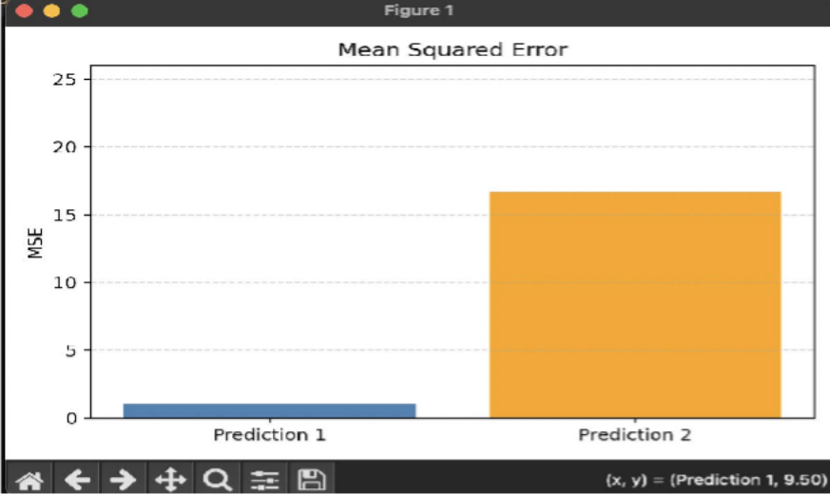
The MSE graph shows that the loss increases as the difference between actual and predicted values increases. Prediction 1 has a lower error (1.0000), while Prediction 2 has a higher error (16.6667).
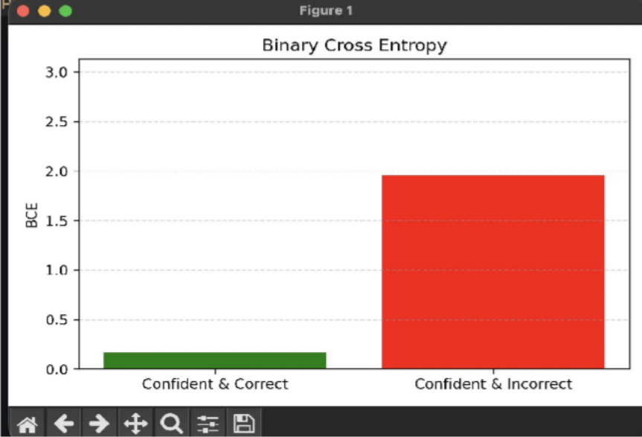
The BCE graph shows that correct and confident predictions produce a low loss (0.1643), while confident but incorrect predictions produce a much higher loss (1.9560). This demonstrates that BCE strongly penalizes incorrect classification predictions.

Observation Table:

Table 1: Activation Function Characteristics

Function | Lower Bound | Upper Bound | Output Range | Output at x = 0 | Behavior as x → -∞ | Behavior as x → +∞
Sigmoid | 0 | 1 | (0, 1) | 0.5 | Approaches 0 | Approaches 1
Tanh | -1 | 1 | (-1, 1) | 0 | Approaches  -1 | Approaches 1
ReLU | 0 | ∞ | [0, ∞) | 0 | Remains 0 | Increases linearly
Leaky ReLU | -∞ | ∞ | (-∞, ∞) | 0 | Decreases linearly with slope 0.01 | Increases linearly with slope 1

Table 2: Loss Function Response to Errors

Scenario | Target (y) | Prediction (ŷ) | Computed Loss | Primary Observation
MSE  Case 1 | [10, 20,  30] | [11, 19, 31] | 1.0000 | Small prediction errors produce a small loss.
MSE  Case 2 | [10, 20,  30] | [15, 20, 25] | 16.6667 | Larger prediction errors produce a much higher loss.
BCE  Case 1 | [1, 0, 1,  0] | [0.9, 0.1,  0.8, 0.2] | 0.1643 | Predictions are close to the correct classes, so loss is low.
BCE  Case 2 | [1, 0, 1,  0] | [0.1, 0.9,  0.2, 0.8] | 1.9560 | Predictions are confidently wrong, so loss is much higher.

- Why does Sigmoid cause gradients to approach zero when inputs are very large or very small? How does ReLU address this?
Sigmoid produces an S-shaped curve and its gradient becomes very small when the input is very large or very small. This causes vanishing gradients, which can slow down learning in deep neural networks. ReLU addresses this for positive inputs because its gradient is 1, allowing gradients to pass through more effectively. However, ReLU can have zero gradient for negative inputs.
- Why is adding an epsilon value necessary when implementing log-based loss functions in software?
An epsilon value is added to prevent taking the logarithm of 0. Since (\log(0)) is undefined and can produce numerical errors such as infinity or NaN, a very small value such as (10^{-15}) is used to keep the computation numerically stable.
- In binary classification, what happens to the Binary Cross-Entropy loss when the model prediction approaches complete confidence in the wrong answer?
The Binary Cross-Entropy loss becomes very large when the model is highly confident but wrong. (For example, if: yactual =1,ypred =0) the prediction is almost completely wrong, so the BCE loss becomes very high. As the prediction gets closer to 0, the loss approaches infinity.

Practical 4

AIM: Mathematical Fundamentals, Neuron, and Perceptron
- Exploring Scalar Code:
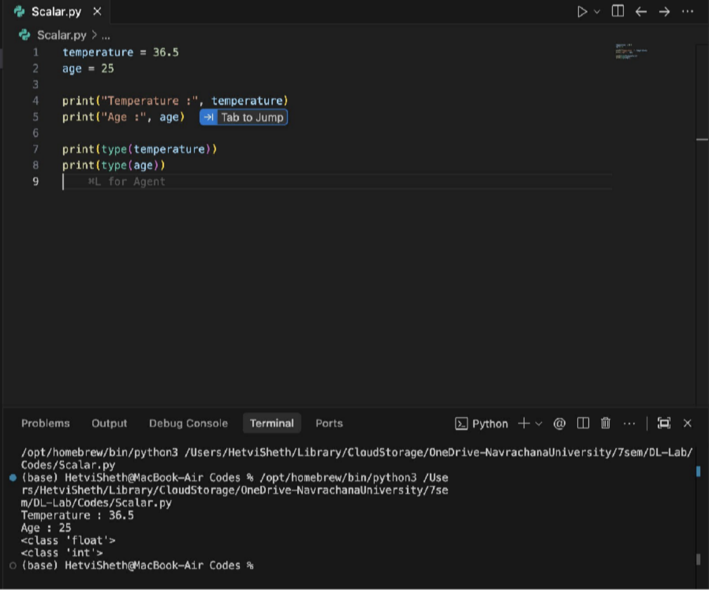

Observation Table:
Variable | Data Type | Dimensions
temperature | float | 0D
age | int | 0D
A scalar contains a single numerical value and has zero dimensions.

- Understanding Vector

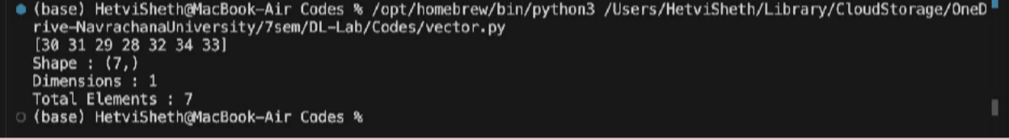
OUTPUT:

Observation table:
Property | Value
Shape | (7,)
Dimensions | 1
Size | 7

- Working with matrices:

OUTPUT:
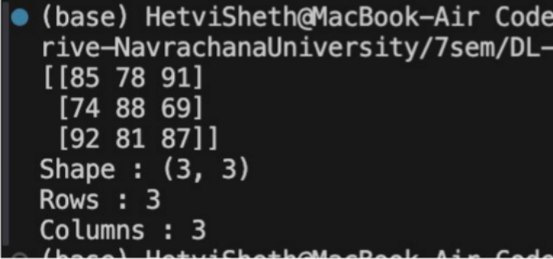

Observation Answer:
  - How many students? 3 Students
  - How many subjects? 3 Subjects

Which element represents Student 2's marks in Subject 3?
marks [1, 2] = 69

Using indexing display Student 1: print (marks [0])
Student 2: print (marks [1])
Subject 3: print (marks [2])

First Tensor:
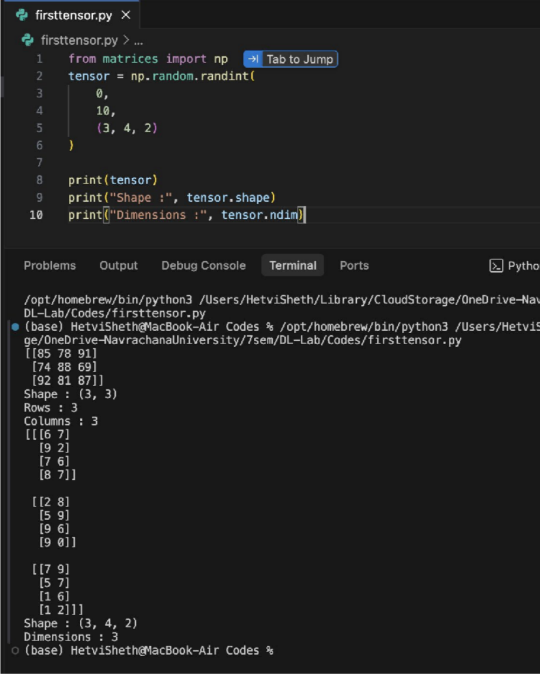
A matrix is generally a 2-dimensional structure containing rows and columns. A tensor can have three or more dimensions and can represent more complex data.
Examples include Images, Videos, Batches of images, Deep-learning datasets

Images as Numerical Data
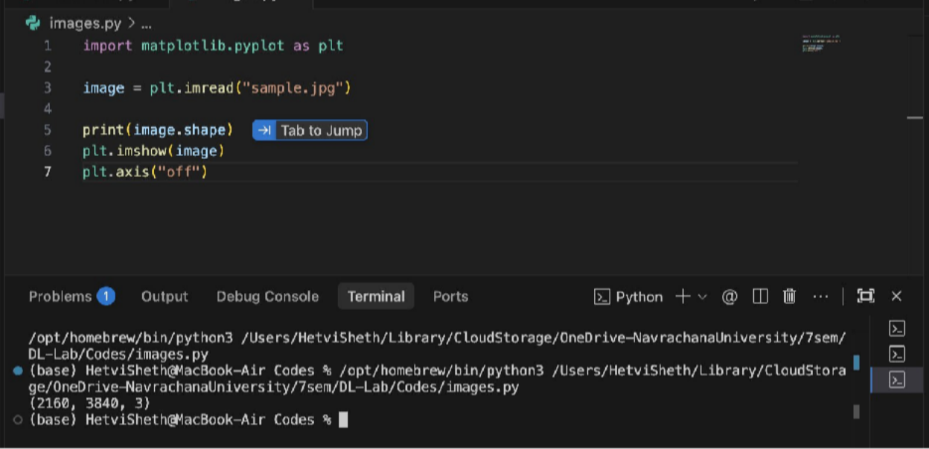

Observation table:
Quantity | Meaning
First Dimension | Height = 512 pixels
Second Dimension | Width = 512 pixels
Third Dimension | RGB channels = 3

512 × 512 represents the image's height and width, while 3 represents Red, Green and Blue channels.

  - RGB Channel:

OUTPUT:


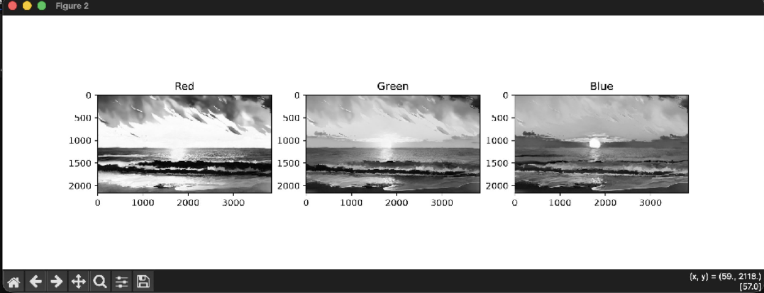
Observation
Which regions appear brighter in the Red channel? Why? Regions containing a higher intensity of red appear brighter in the Red channel because the Red channel stores the red intensity value for each pixel.

Computing a Weighted Sum, Building a Neuron, Applying Step Activation, and Understanding the Role of Bias

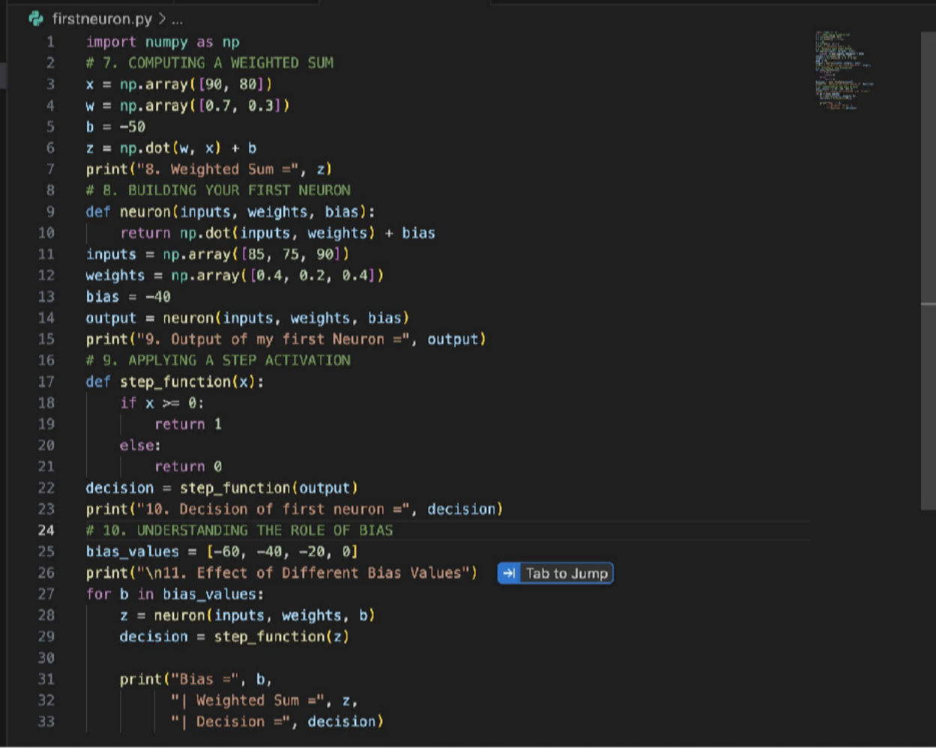
Code:

OUTPUT:
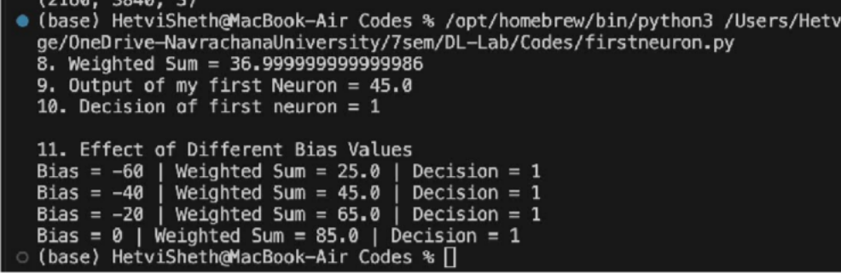

Observation

- The weighted sum of the first neuron was calculated using inputs [90, 80], weights [0.7, 0.3], and bias -50. The resulting weighted sum was 37.
- The first feature contributed more to the decision because its weighted contribution was 63, compared to 24 for the second feature.
- The first neuron was constructed using three inputs, weights, and a bias. Its output was 45.
- The step activation function converted the neuron output 45 into a final decision of 1, since the output was greater than or equal to zero.
- Different bias values -60, -40, -20, 0 changed the weighted sum to 25, 45,
65, and 85, respectively.
- Although the bias changed the weighted sum, all four values remained positive, so the final decision remained 1.

Conclusion
In this experiment, we learned how an artificial neuron calculates a weighted sum using inputs, weights, and bias. We observed that weights determine the contribution of each input, while the bias shifts the weighted sum and affects the neuron's decision boundary. The step activation function converts the numerical output of the neuron into a binary decision of 0 or 1. Thus, the experiment helped us understand the basic working of an artificial neuron and the importance of weights, bias, and activation functions in neural networks.

Practical 6

Aim: Visual analysis of non-linear classification and error dynamics in Multi-Layer Perceptron (MLP)
XOR Problem:
The XOR problem is non-linearly separable, meaning that a single perceptron cannot classify all four points correctly using a single linear decision boundary.
Therefore, a Multi-Layer Perceptron with a hidden layer is used. The laboratory architecture uses two hidden neurons followed by an output neuron.

Python Implementation

Import Libraries and Load Dataset
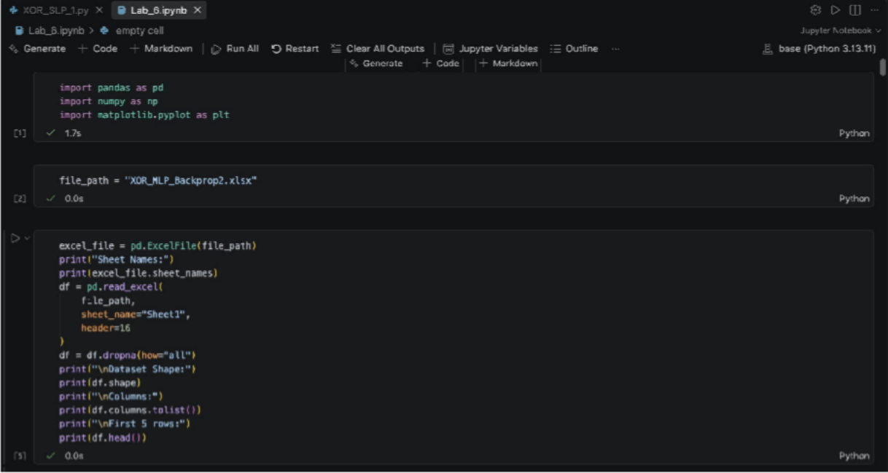

OUTPUT:

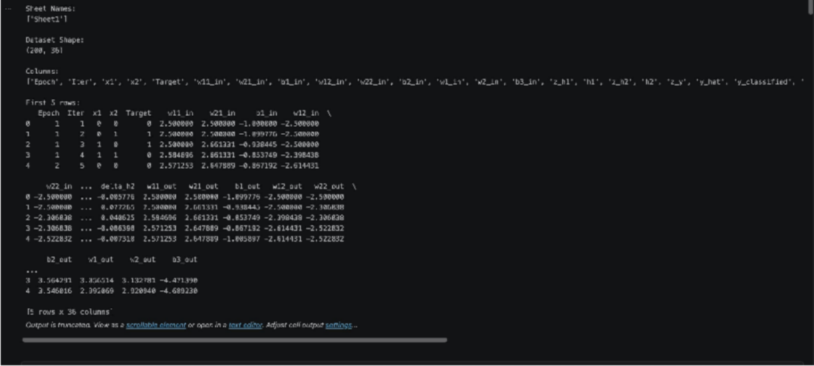
The Excel workbook is first inspected to identify the available worksheets. Since the iteration table header occurs at row 17 of the Excel sheet, header=16 is used because Pandas uses zero-based indexing. Empty rows are removed after loading the dataset.

Data Cleaning and Global Iteration
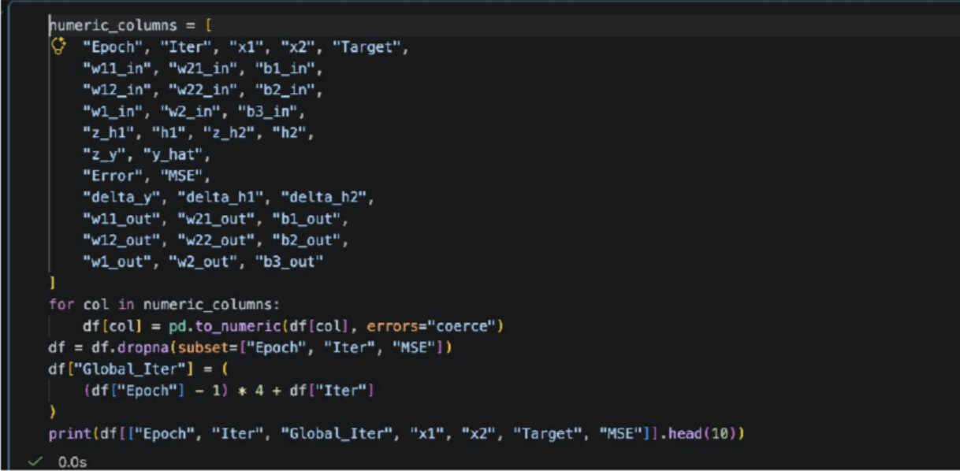

OUTPUT:

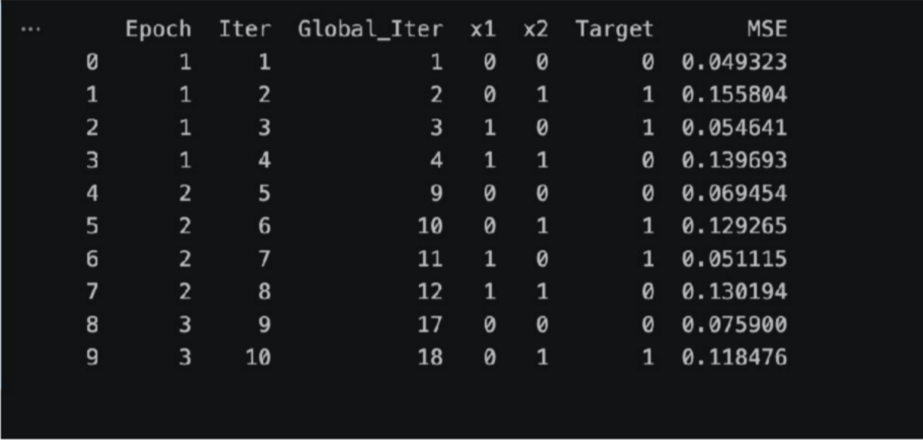
The dataset contains four patterns per epoch, so the Iter column restarts from 1 after every four patterns. A Global_Iter column is therefore created to represent the complete training process from iteration 1 to iteration 200.

Visualization A — Individual Pattern MSE vs Epoch Mean MSE
In online backpropagation, the weights are updated after every individual training pattern. Consequently, the error for an individual pattern can increase or decrease depending on the current weights. This produces oscillations in the individual pattern MSE. The epoch mean MSE averages the errors of the four XOR patterns, resulting in a smoother representation of the overall training progress.
epoch_mean = df.groupby("Epoch")["MSE"].mean() df["Epoch_Mean_MSE"] = df["Epoch"].map(epoch_mean) plt.figure(figsize=(12, 6))
plt.plot(
df["Global_Iter"], df["MSE"],
label="Individual Pattern MSE", linewidth=1.5
)

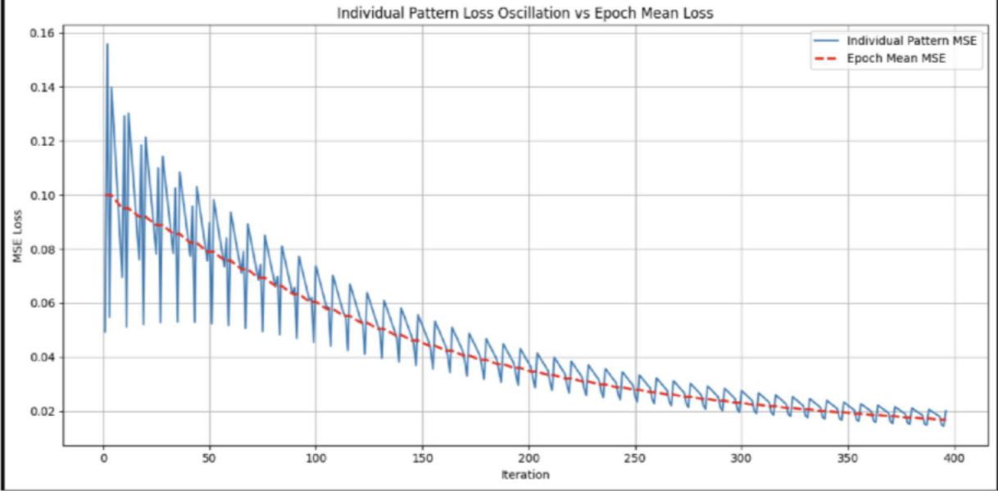
plt.plot(
df["Global_Iter"], df["Epoch_Mean_MSE"], "r--",
linewidth=2, label="Epoch Mean MSE"
)
plt.xlabel("Iteration") plt.ylabel("MSE Loss")
plt.title("Individual Pattern Loss Oscillation vs Epoch Mean Loss") plt.legend()
plt.grid(True) plt.tight_layout() plt.show()

OUTPUT:
Figure 1: Individual Pattern Loss Oscillation vs Epoch Mean Loss Observation: The individual pattern MSE shows fluctuations across iterations because the weights are updated after each training pattern. In contrast, the epoch mean MSE provides a smoother trend and generally decreases as training progresses.

Visualization B — MSE vs Average Weight Trajectory

Weight trajectory analysis shows how the model parameters change during training. As backpropagation minimizes the error, the weights are continuously adjusted. Comparing MSE with the average absolute weight provides an indication of how parameter changes are associated with the training process.
The lab also suggests analyzing the sum of all weights across iterations.
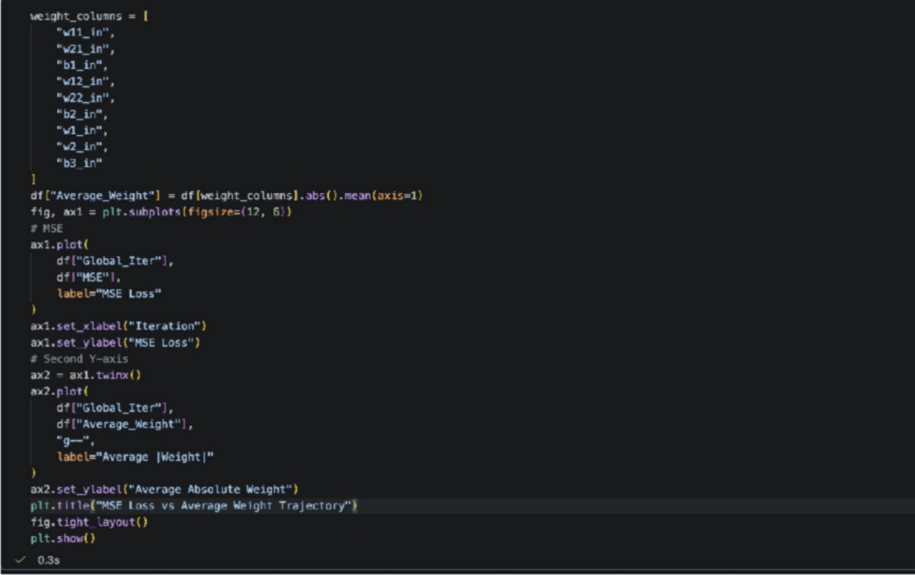

OUTPUT:

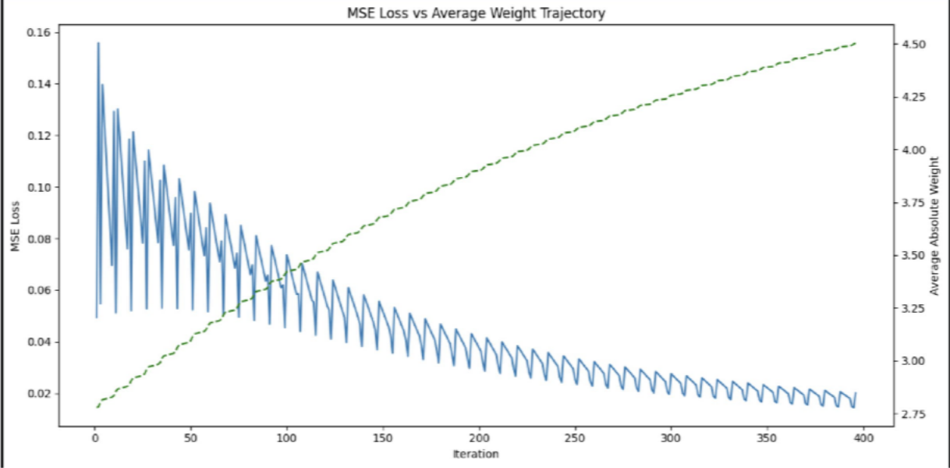
Figure 2: MSE Loss vs Average Weight Trajectory Observation: The MSE generally decreases as training progresses, while the network weights adjust to reduce the prediction error. The weight trajectory demonstrates the parameter adaptation performed by backpropagation.
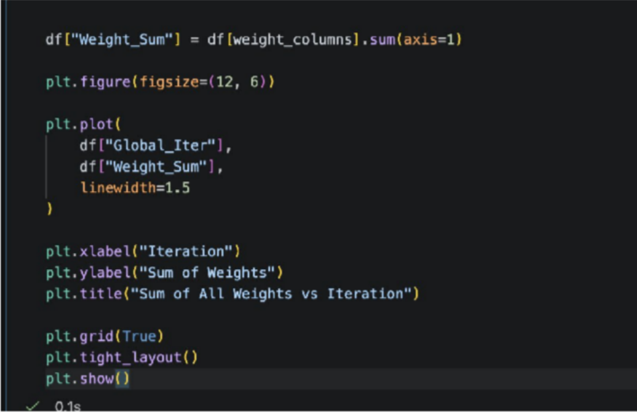

OUTPUT:

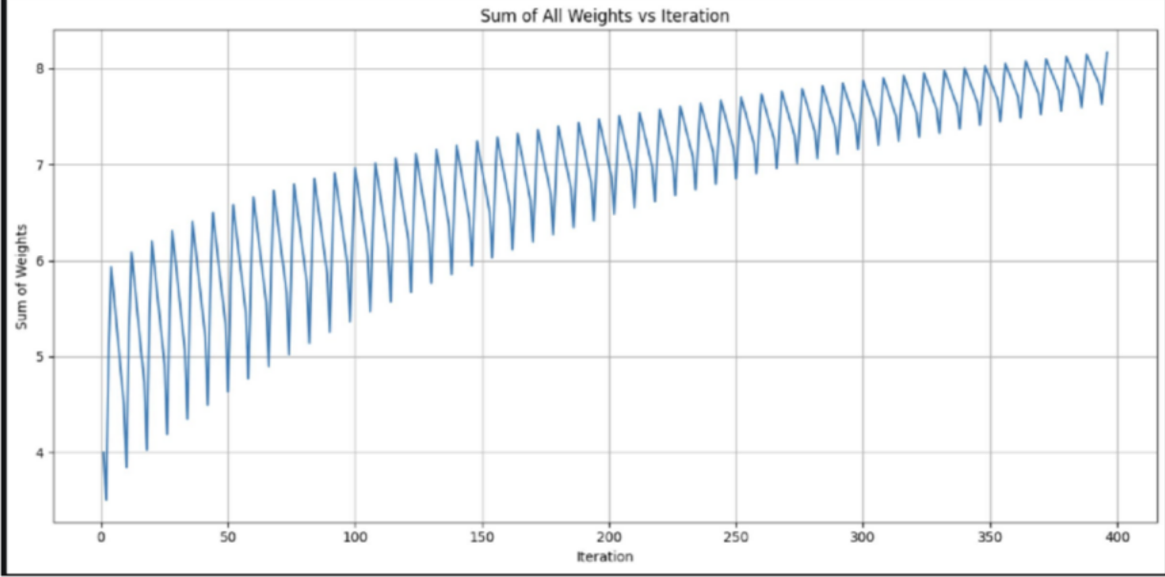

Visualization C — Hidden Space Transformation
The hidden layer performs a nonlinear transformation of the original XOR inputs. Instead of directly separating the four input patterns in the original x1−x2 space, the network maps them into a new h1−h2feature space. The hidden representation can make the XOR classes separable for the output layer.
plt.figure(figsize=(8, 7)) patterns = [
(0, 0),
(0, 1),
(1, 0),
(1, 1)
]
for x1, x2 in patterns: subset = df[
(df["x1"] == x1) &
(df["x2"] == x2)
]
plt.scatter( subset["h1"],

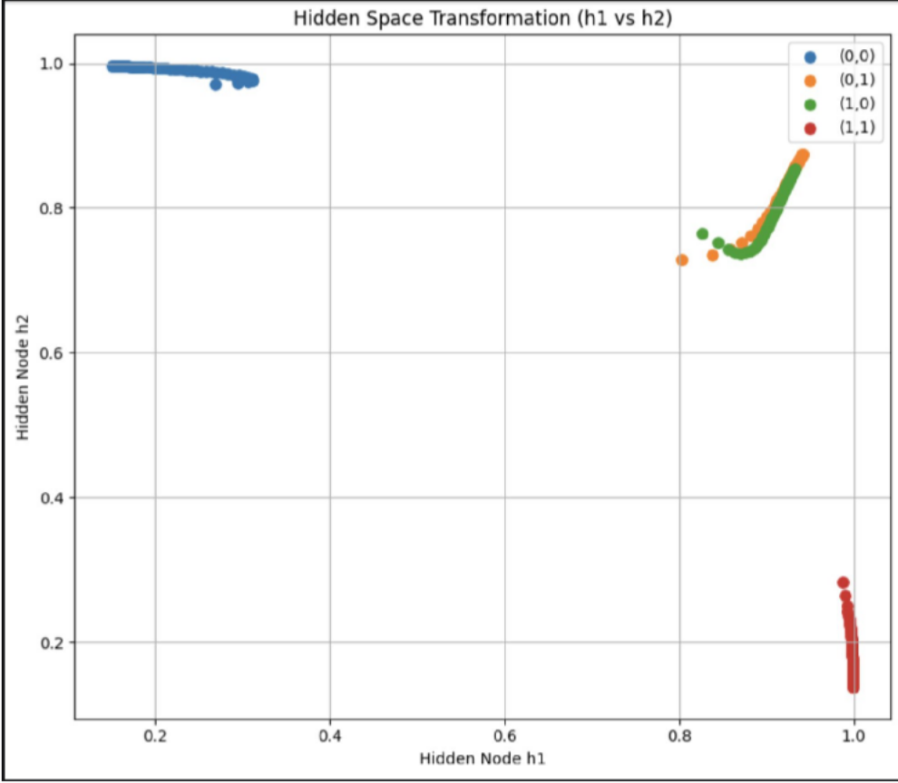
subset["h2"], s=45,
label=f"({x1},{x2})"
)
plt.xlabel("Hidden Node h1") plt.ylabel("Hidden Node h2")
plt.title("Hidden Space Transformation (h1 vs h2)") plt.legend()
plt.grid(True) plt.tight_layout() plt.show()

OUTPUT:
Figure 3: Hidden Space Transformation — h1 vs h2 Observation: The hidden neurons transform the original XOR input patterns into a new feature space. The resulting h1−h2 representation

creates distinct regions for the XOR patterns, allowing the output layer to perform the final classification.

Visualization D — Learning Rate Comparison
The learning rate η controls the magnitude of weight updates during gradient descent. A small learning rate results in smaller updates, whereas a high learning rate results in larger parameter changes. The experiment compares η=0.5, η=2.5, and η=4.5 to study their effects on convergence and weight trajectories.

XOR Dataset and Sigmoid
PUT THIS CODE
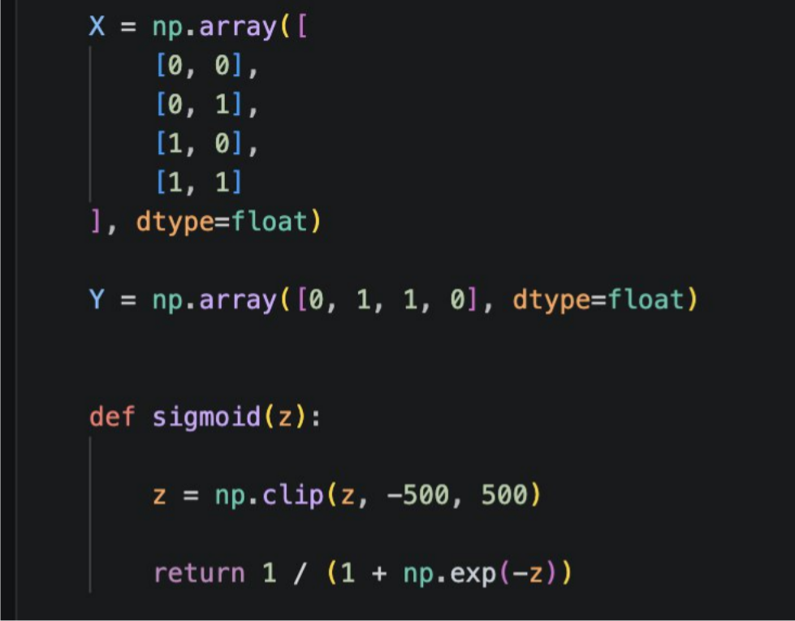

  - MLP Training Function
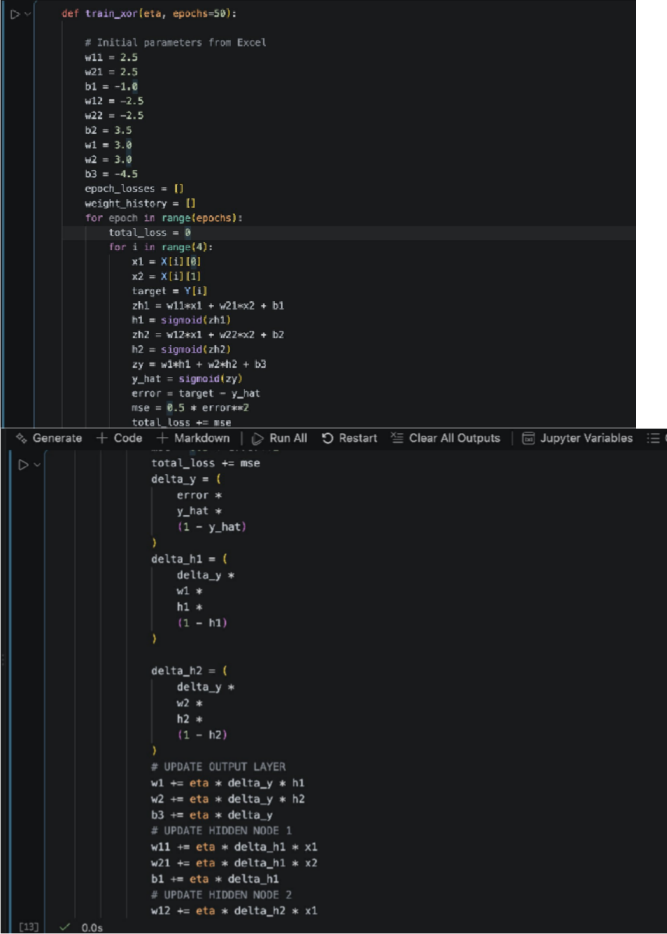

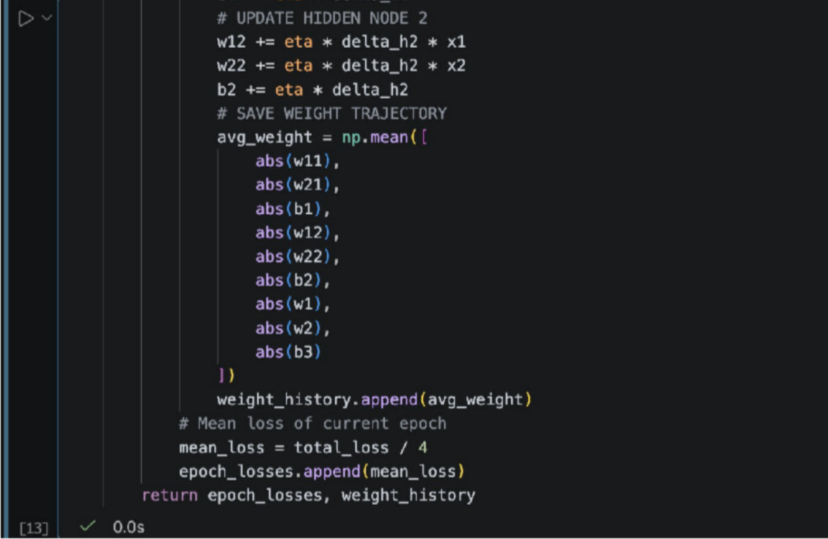

Compare Learning Rates
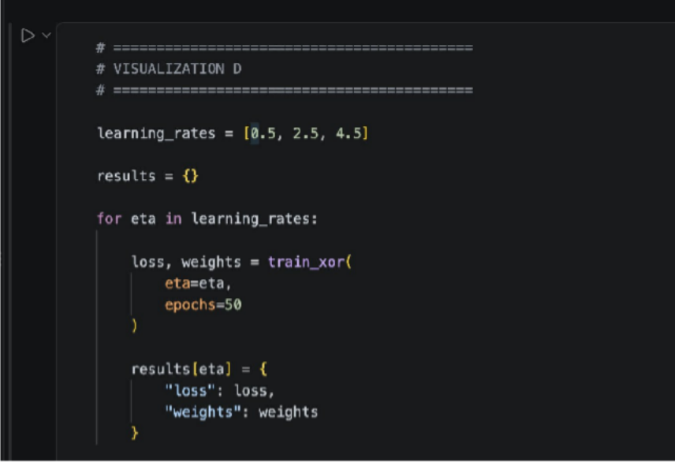

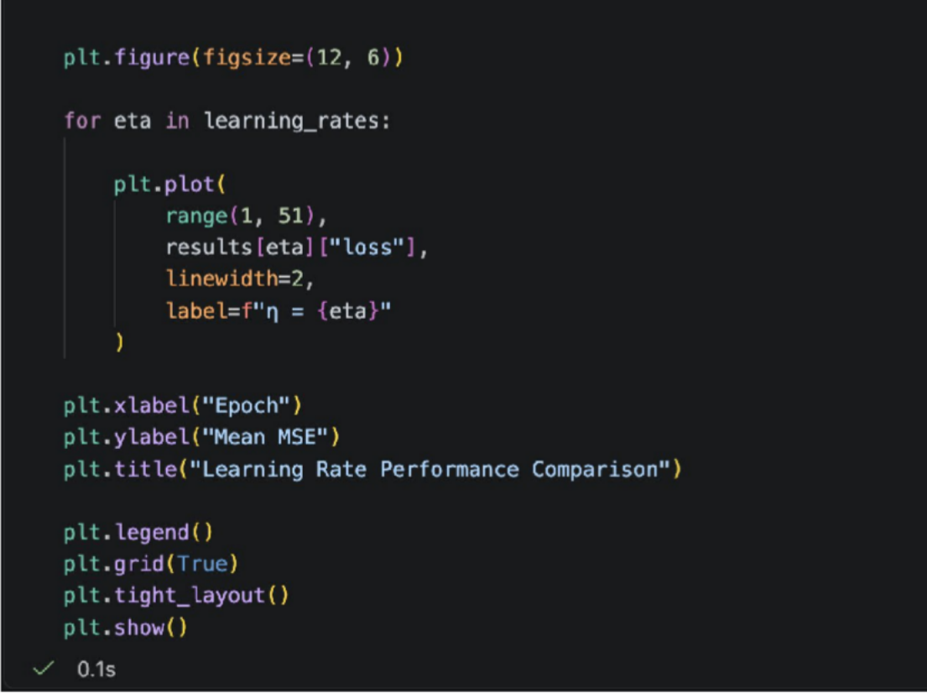
Plot Learning Rate Performance

OUTPUT:
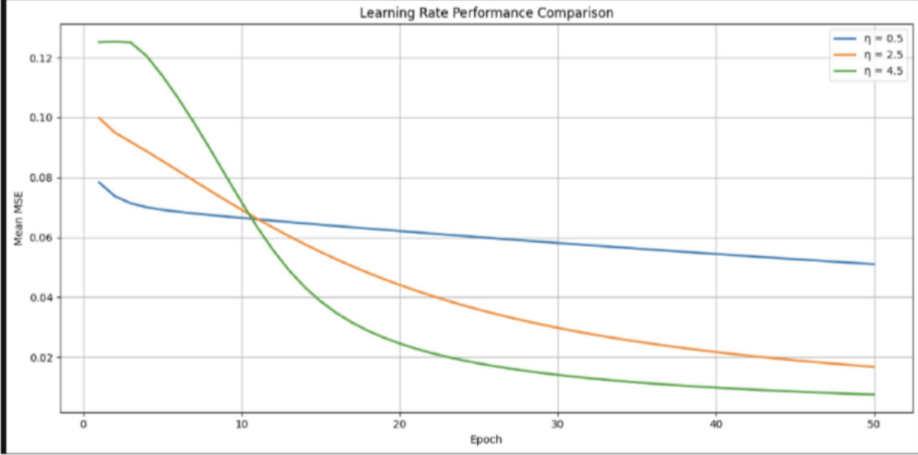

Figure 4: Learning Rate Performance Comparison Observation: The learning rate affects both the speed and stability of training. A higher learning rate produces larger weight updates and can

result in stronger oscillations or overshooting. A more suitable learning rate produces smoother parameter adaptation and more stable error reduction.

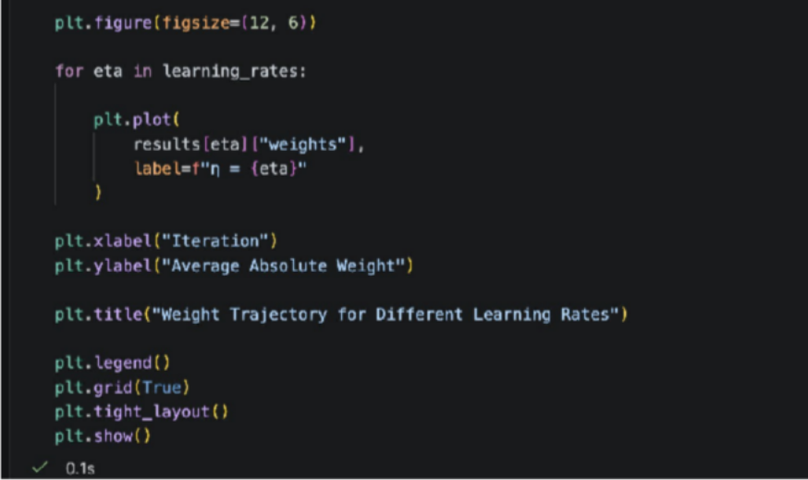
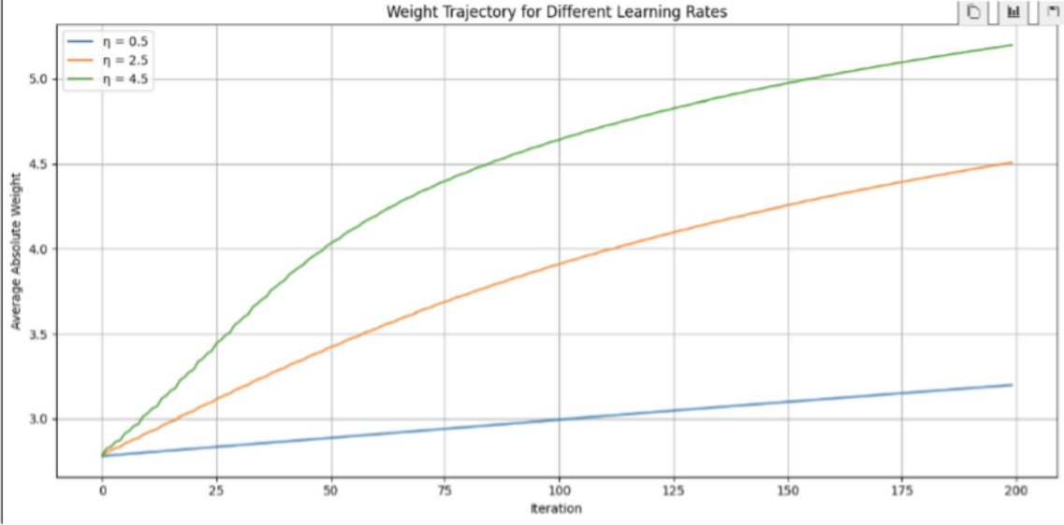
Weight Trajectory Comparison

OUTPUT:
Figure 5: Weight Trajectory for Different Learning Rates Observation: The learning rate of 4.5 produces larger changes in the weight trajectory because each gradient update is multiplied by a larger learning-rate value. The trajectory for 2.5 can be compared with 0.5 to observe the difference between relatively larger and smaller updates.

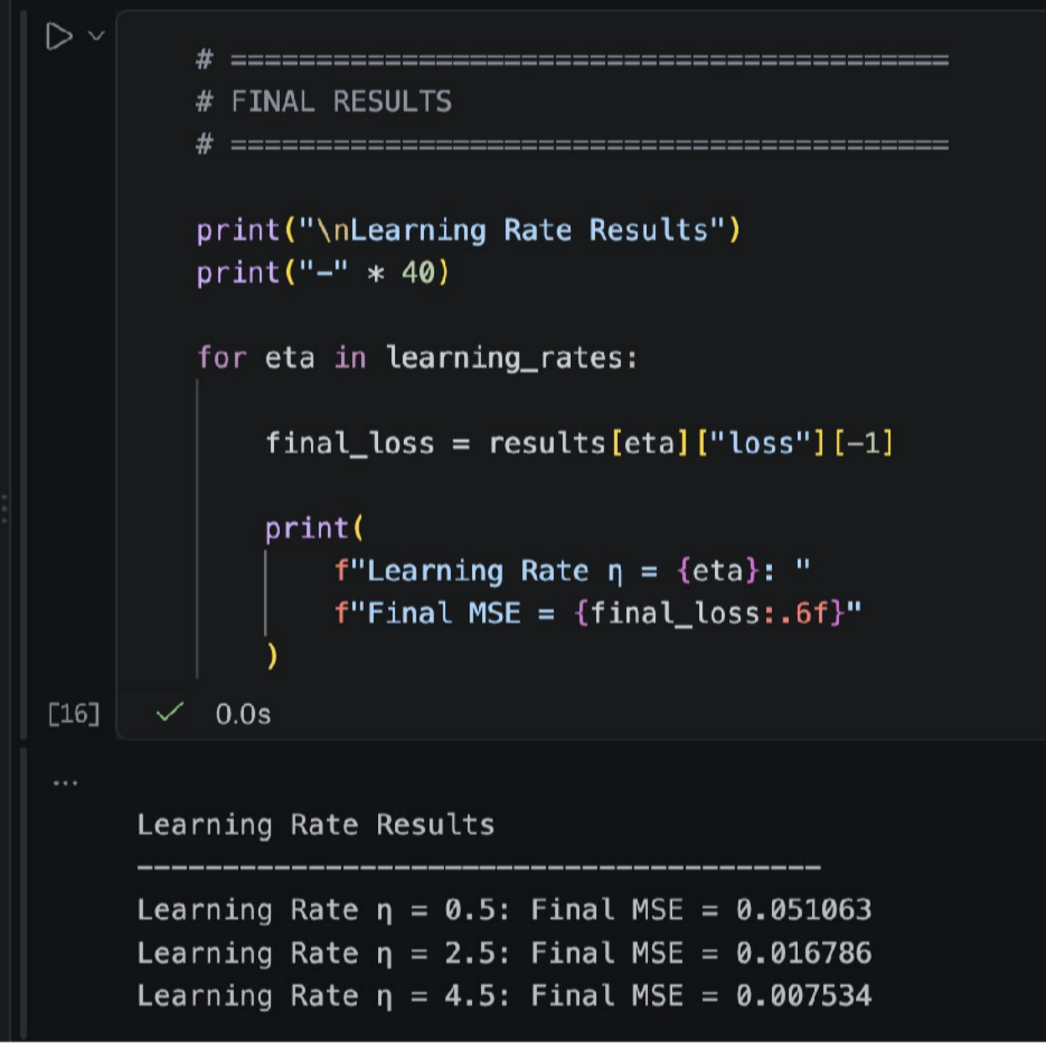

Extended Visual Analysis

Task 1: Gradient Magnitude Trajectory and Vanishing Gradient Analysis
To plot the absolute magnitude of the output error gradient ∣δy∣ alongside the
hidden-layer gradients ∣δh1∣and ∣δh2∣ across training iterations.
The objective is to visualize how the gradient signal changes as it propagates backward from the output layer toward the hidden layer.
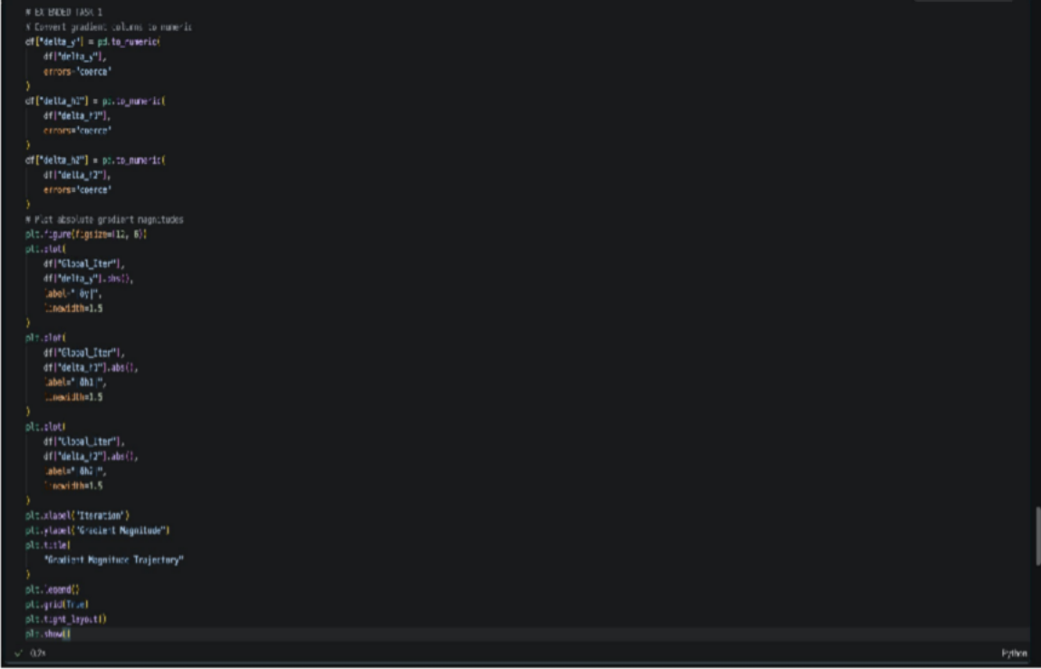
Code

OUTPUT:

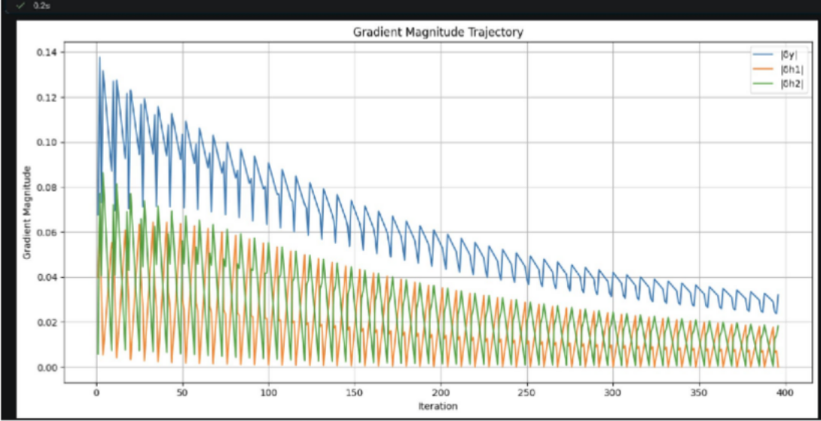
Figure 6: Gradient Magnitude Trajectory and Vanishing Gradient Analysis Observation
The output gradient generally has a larger magnitude because it is calculated directly from the output error. The hidden-layer gradients are obtained by propagating this signal through the output weights and sigmoid derivatives. Smaller hidden gradients indicate attenuation of the gradient during backward propagation. The graph therefore provides a visual representation of possible gradient attenuation.

Task 2: Individual Weight and Bias Evolution Pathways Objective: To plot the individual trajectories of the input-to-hidden weights w11, w21, w12, w22, hidden-to-output weights v1, v2, and biases throughout training. Code
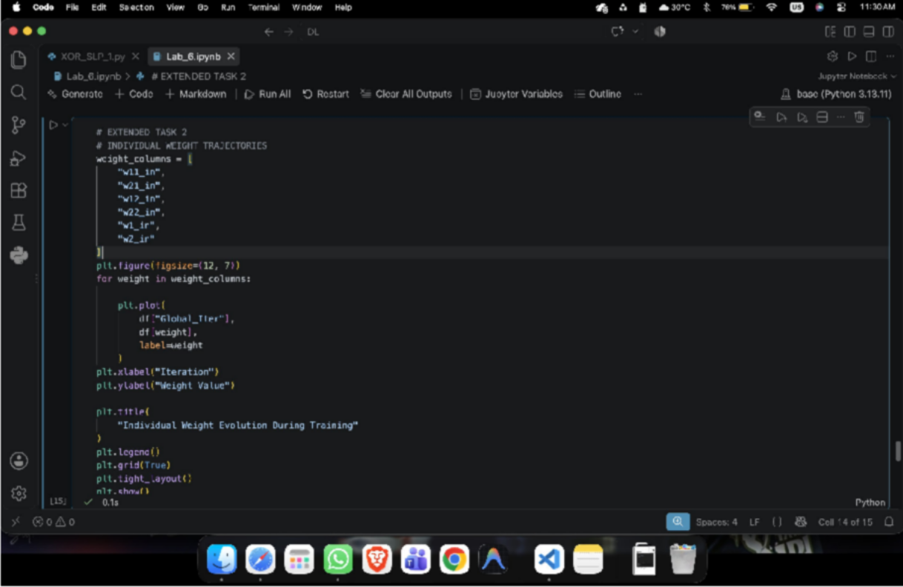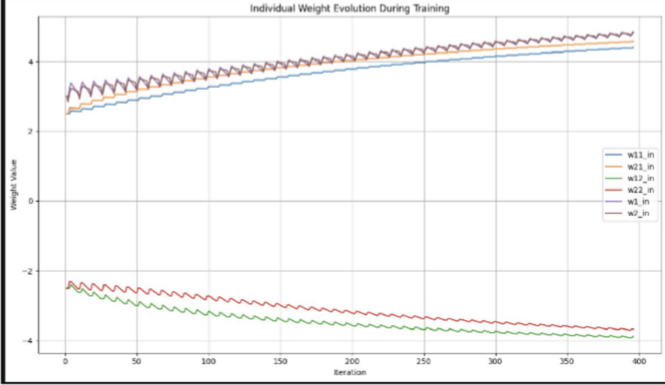

OUTPUT:
Figure 7: Individual Weight Evolution During Training INDIVIDUAL BIAS TRAJECTORIES

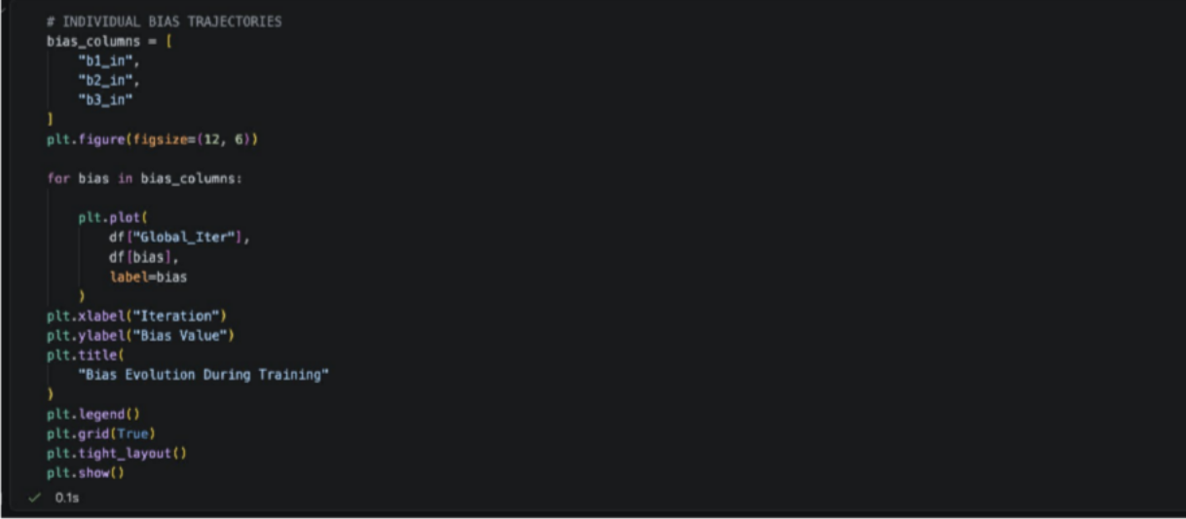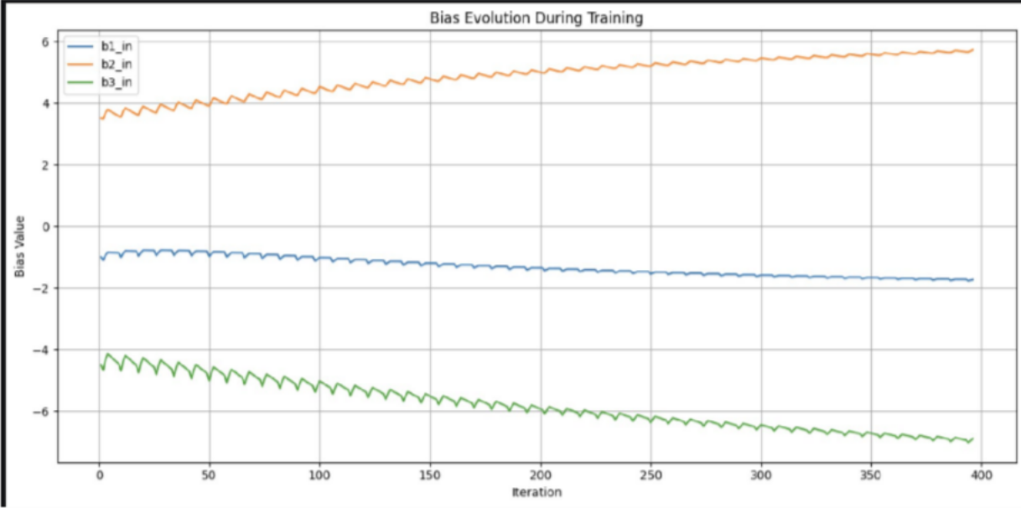

OUTPUT:
Figure 8: Bias Evolution During Training
Observation
The individual parameter trajectories show that different weights and biases change at different rates during training. This occurs because each parameter receives a gradient based on the current input, activation values and propagated error. The trajectories demonstrate how the network gradually adapts its internal parameters to learn the XOR decision function. The lab describes this analysis as illustrating how specific weights adapt to form distinct internal decision logic.

Task 3: Decision Boundary Movement
Objective

To plot the hidden-layer decision boundary lines zh1=0 and zh2=0 in the original input space (x1,x2) at epochs 1, 10, 25 and 50.
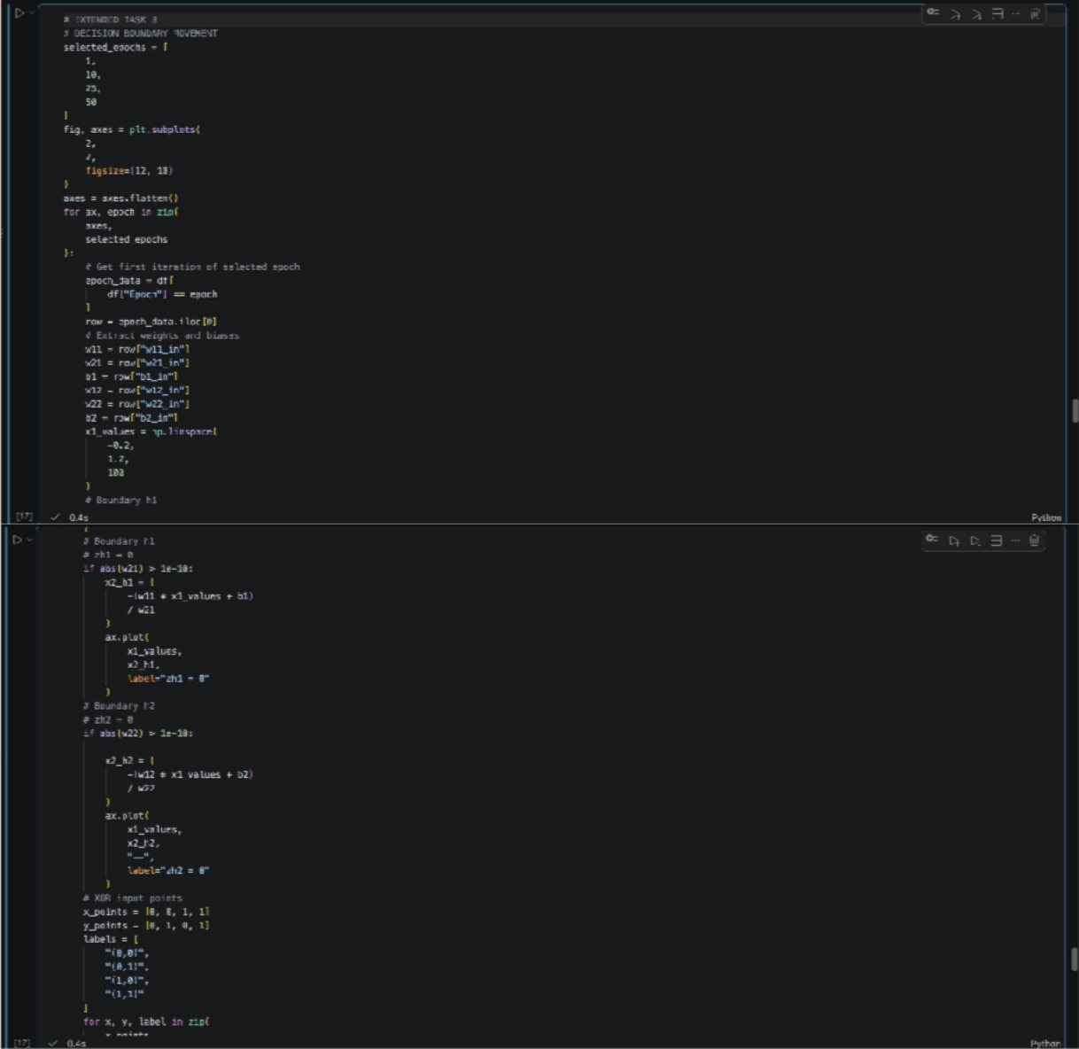

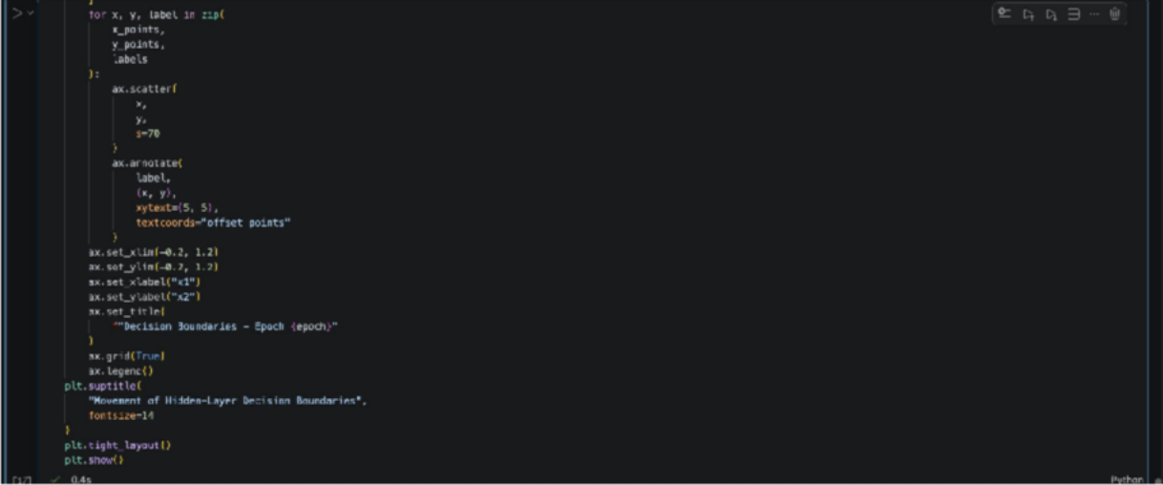
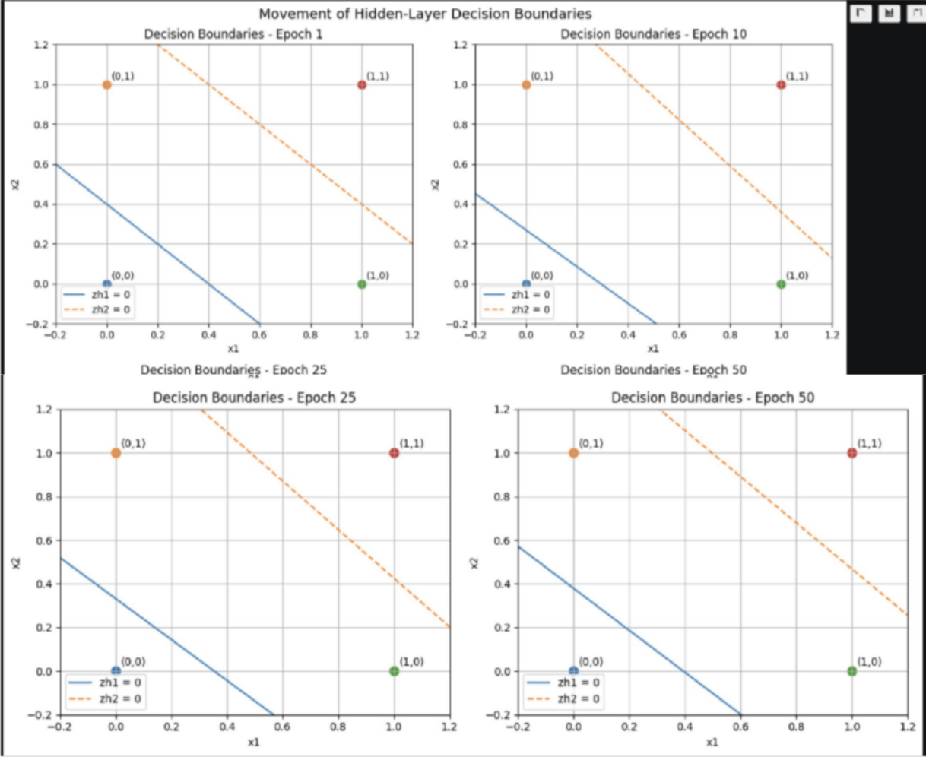
OUTPUT:

Figure 9: Decision Boundary Movement at Epochs 1, 10, 25 and 50 Observation

The decision-boundary subplots show how the hidden-layer boundaries change as the network is trained. Changes in the weights modify the slope of the boundary, while changes in the biases shift its position. The movement of these boundaries represents the adaptation of the hidden layer toward a feature representation suitable for XOR classification.

Practical: 7

From-scratch implementation of Single-Layer (SLP) and Multi-Layer Perceptron (MLP) without AI frameworks Aim: To design, program, and evaluate Single-Layer Perceptron (SLP)
and Multi-Layer Perceptron (MLP) from first principles using pure Python and low-level matrix mechanics, eliminating dependencies on high-level AI/ML frameworks (e.g., PyTorch, TensorFlow, Scikit-learn).
- Weighted Sum
z = w₁x₁ + w₂x₂ + ⋯ + wₙxₙ + b
- Decision Boundary w₁x₁ + w₂x₂ + b = 0
- Sigmoid Activation σ(z) = 1 / (1 + e⁻ᶻ)
- Sigmoid Derivative
σ′(z) = σ(z)(1 − σ(z))
- Mean Squared Error (MSE) MSE = (1/n) Σᵢ₌₁ⁿ (yᵢ − ŷᵢ)²
- SLP Local Gradient δᵧ = (y − ŷ)σ′(z)
- Gradient Descent Weight Update
w_new = w_old − η(∂L/∂w)
- Bias Update
b_new = b_old − η(∂L/∂b)
- MLP Hidden Layer Z₁ = XW₁ + B₁
- Hidden Layer Activation A₁ = σ(Z₁)
- MLP Output Layer Z₂ = A₁W₂ + B₂
- Predicted Output Ŷ = σ(Z₂)
- Output Layer Delta – MSE δ₂ = (Ŷ − Y) ⊙ Ŷ(1 − Ŷ)
- Output Weight Gradient dW₂ = (A₁ᵀδ₂) / n
- Output Bias Gradient

db₂ = (1/n) Σδ₂
- Hidden Layer Delta δ₁ = (δ₂W₂ᵀ) ⊙ σ′(Z₁)
- Hidden Weight Gradient dW₁ = (Xᵀδ₁) / n
- Hidden Bias Gradient db₁ = (1/n) Σδ₁
- Output Weight Update W₂ = W₂ − ηdW₂
- Output Bias Update B₂ = B₂ − ηdb₂
- Hidden Weight Update W₁ = W₁ − ηdW₁
- Hidden Bias Update B₁ = B₁ − ηdb₁
- Tanh Activation
tanh(z) = (eᶻ − e⁻ᶻ) / (eᶻ + e⁻ᶻ)
- Tanh Derivative
d(tanh(z))/dz = 1 − tanh²(z)
- Tanh Hidden Delta δ₁ = (δ₂W₂ᵀ) ⊙ (1 − A₁²)
- Binary Cross-Entropy (BCE)
L_BCE = −(1/n) Σᵢ₌₁ⁿ [yᵢ log(ŷᵢ) + (1 − yᵢ)log(1 − ŷᵢ)]
- BCE + Sigmoid Output Gradient δ₂ = Ŷ − Y
- BCE Hidden Delta δ₁ = (δ₂W₂ᵀ) ⊙ σ′(Z₁)
- Binary Prediction
ŷ_class = 1 if ŷ ≥ 0.5; otherwise 0
- ReLU
ReLU(z) = max(0, z)
- XOR Baseline MSE
MSE = 0.25
- Chain Rule
∂L/∂W = (∂L/∂Ŷ)(∂Ŷ/∂Z)(∂Z/∂W)

PurePythonSLP.py

Cell 1 — Dataset
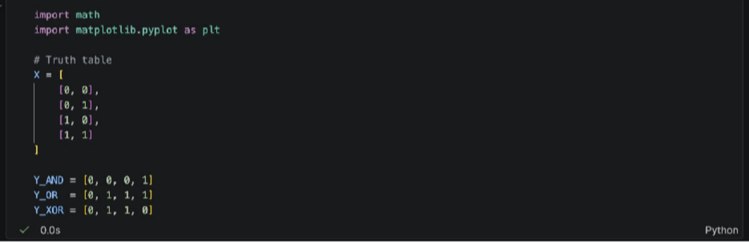
Defines the truth-table inputs and target outputs for the AND, OR, and XOR logic gates.

Cell 2 — SLP Class
class PurePythonSLP:
def _init_(self, learning_rate=1.0): self.weights = [0.1, 0.1]
self.bias = 0.1
self.learning_rate = learning_rate def sigmoid(self, z):
z = max(min(z, 500), -500)
return 1 / (1 + math.exp(-z)) def forward(self, x):
z = (
self.weights[0] * x[0]
+ self.weights[1] * x[1]
+ self.bias
)
y_hat = self.sigmoid(z) return z, y_hat
def train(self, X, Y, epochs=5000): loss_history = []
for epoch in range(epochs): total_loss = 0
for x, y in zip(X, Y): # Forward pass
z, y_hat = self.forward(x)

# Error
error = y_hat - y total_loss += error ** 2 # Sigmoid derivative
derivative = y_hat * (1 - y_hat) # Local gradient
delta = error * derivative # Weight updates self.weights[0] -= (
self.learning_rate * delta * x[0]
)
self.weights[1] -= ( self.learning_rate * delta * x[1]
)
# Bias update self.bias -= (
self.learning_rate * delta
)
# MSE
mse = total_loss / len(X) loss_history.append(mse)
return loss_history
def predict_probability(self, x): return self.forward(x)[1]
def predict(self, x):
return 1 if self.predict_probability(x) >= 0.5 else 0
Implements a Single-Layer Perceptron from scratch using pure Python with sigmoid activation, forward propagation, gradient descent, and prediction.

Cell 3 — Training and Prediction
#AND Gate
slp_and = PurePythonSLP(learning_rate=5.0) and_loss = slp_and.train(
X, Y_AND,
epochs=5000
)
print("========== AND GATE ==========")
print("Weights:", slp_and.weights)

print("Bias:", slp_and.bias) print("Final MSE:", and_loss[-1]) for x in X:
print( x,
"-> Probability:", round(slp_and.predict_probability(x), 4), "Prediction:",
slp_and.predict(x)
)
# OR GATE
slp_or = PurePythonSLP(learning_rate=5.0) or_loss = slp_or.train(
X, Y_OR,
epochs=5000
)
print("\n========== OR GATE ==========")
print("Weights:", slp_or.weights) print("Bias:", slp_or.bias) print("Final MSE:", or_loss[-1]) for x in X:
print( x,
"-> Probability:", round(slp_or.predict_probability(x), 4), "Prediction:",
slp_or.predict(x)
)
# XOR GATE
slp_xor = PurePythonSLP(learning_rate=1.0) xor_loss = slp_xor.train(
X, Y_XOR,
epochs=5000
)
print("\n========== XOR GATE ==========")
print("Weights:", slp_xor.weights) print("Bias:", slp_xor.bias) print("Final MSE:", xor_loss[-1])

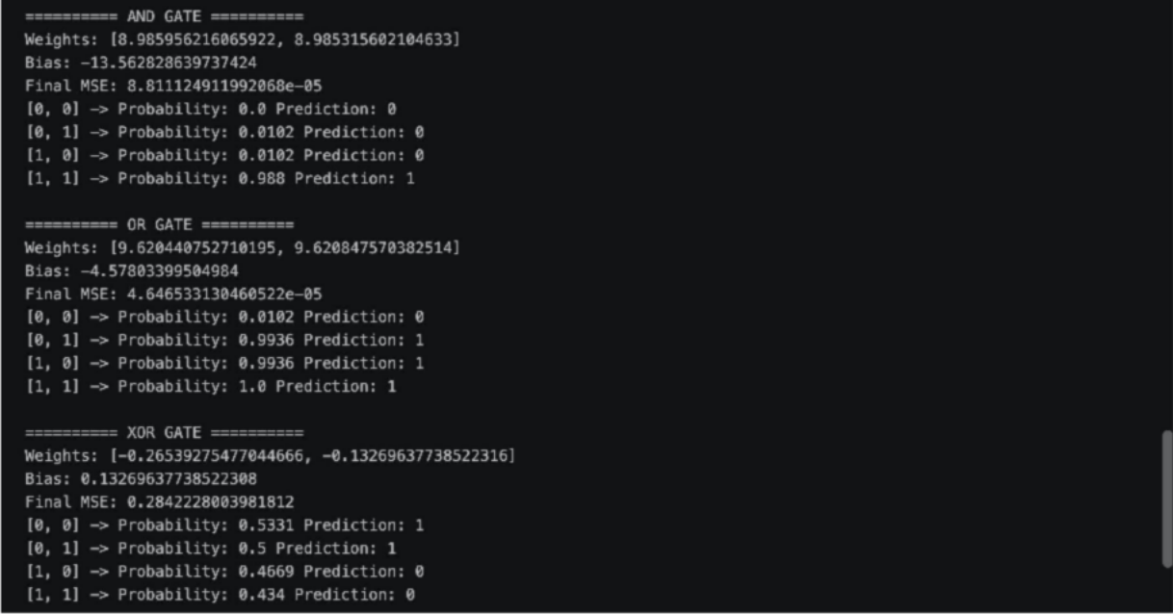
for x in X: print(
x,
"-> Probability:", ound(slp_xor.predict_probability(x), 4), "Prediction:",
slp_xor.predict(x)
)

OUTPUT:
Trains separate SLP models for AND, OR, and XOR and displays their weights, bias, loss, probabilities, and predicted outputs.

Cell 4 — Loss Graphs

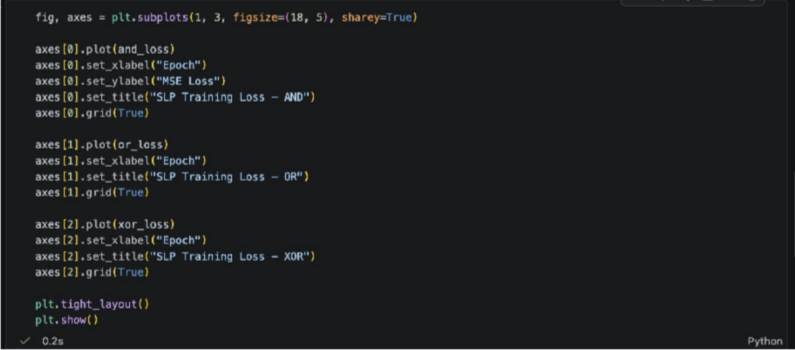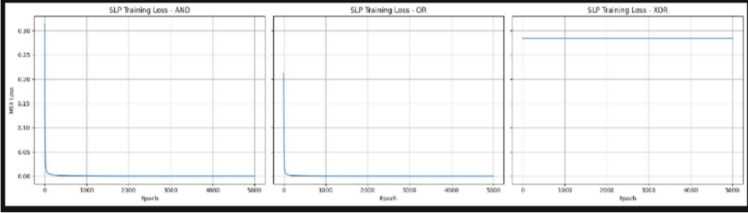

OUTPUT:
Plots the MSE loss over epochs for AND, OR, and XOR to visualize the training behavior.
The SLP successfully learns the linearly separable AND and OR gates, while it cannot perfectly learn XOR because XOR is not linearly separable.

ScratchMLP.ipynb

Cell 1 — Dataset
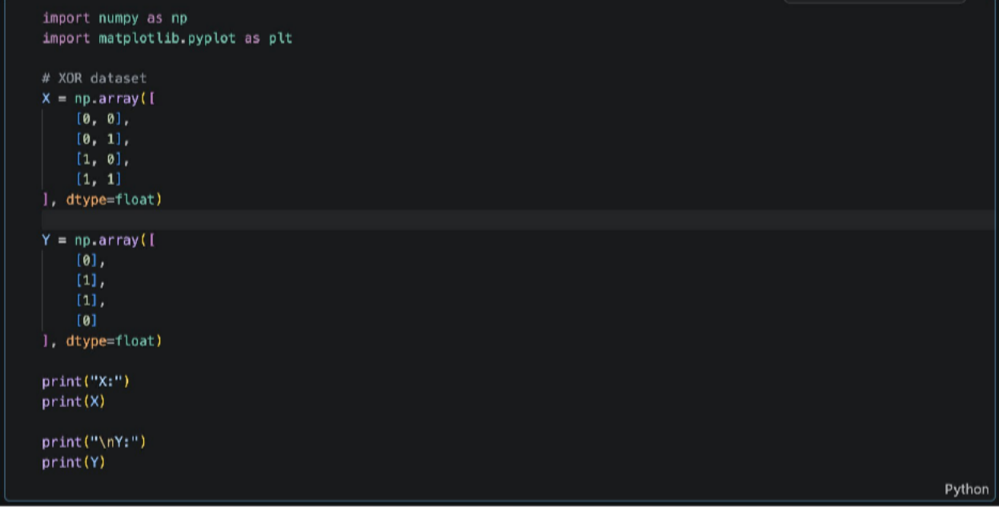
Creates the XOR dataset using NumPy arrays for training the multi-layer perceptron.

Cell 2 — MLP Class
class ScratchMLP: def _init_(
self, input_size=2, hidden_size=2, output_size=1, learning_rate=3.0, seed=42
):
self.learning_rate = learning_rate rng = np.random.default_rng(seed) # Input -> Hidden
self.W1 = rng.normal( 0,
0.5,
(input_size, hidden_size)
)
hidden_size)
)

self.b1 = np.zeros((1, hidden_size)) # Hidden -> Output
self.W2 = rng.normal( 0,
0.5,
(hidden_size, output_size)
)
self.b2 = np.zeros((1, output_size)) # Sigmoid
def sigmoid(self, z):
z = np.clip(z, -500, 500)
return 1 / (1 + np.exp(-z)) # Forward propagation
def forward(self, X): # Hidden layer
self.Z1 = X @ self.W1 + self.b1 self.A1 = self.sigmoid(self.Z1) # Output layer
self.Z2 = self.A1 @ self.W2 + self.b2 self.Y_hat = self.sigmoid(self.Z2) return self.Y_hat
#MSE
def calculate_loss(self, Y, Y_hat): return np.mean(
(Y - Y_hat) ** 2
)
# Training
def train(self, X, Y, epochs=10000): loss_history = []
n = X.shape[0]
for epoch in range(epochs): # Forward propagation Y_hat = self.forward(X) # Loss
loss = self.calculate_loss( Y,
Y_hat
)
loss_history.append(loss)

# Output delta delta2 = (
(Y_hat - Y)
- Y_hat
- (1 - Y_hat)
)
#Output gradients dW2 = (
self.A1.T @ delta2
) / n db2 = (
np.sum(
delta2, axis=0,
keepdims=True
) / n
)
# Hidden delta delta1 = (
delta2 @ self.W2.T
) * self.A1 * (1 - self.A1) # Hidden gradients
dW1 = (
X.T @ delta1
) / n db1 = (
np.sum(
delta1, axis=0,
keepdims=True
) / n
)
# Update parameters
self.W2 -= self.learning_rate * dW2 self.b2 -= self.learning_rate * db2
self.W1 -= self.learning_rate * dW1 self.b1 -= self.learning_rate * db1
return loss_history

# Prediction
def predict_probability(self, X): return self.forward(X)
def predict(self, X): return (
self.predict_probability(X) >= 0.5
).astype(int)
Implements a 2–2–1 Multi-Layer Perceptron from scratch using NumPy, sigmoid activation, forward propagation, and backpropagation.

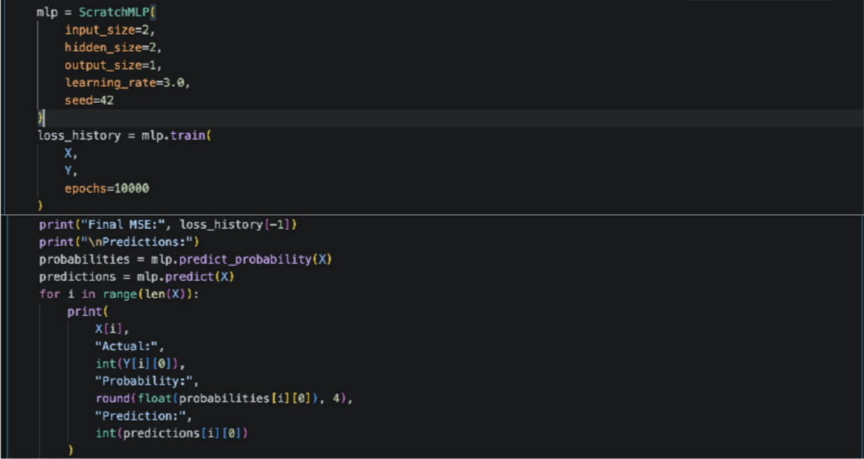
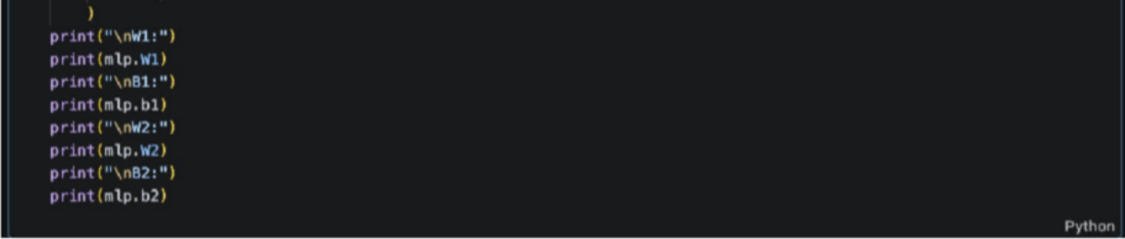
Cell 3 — Training and Prediction

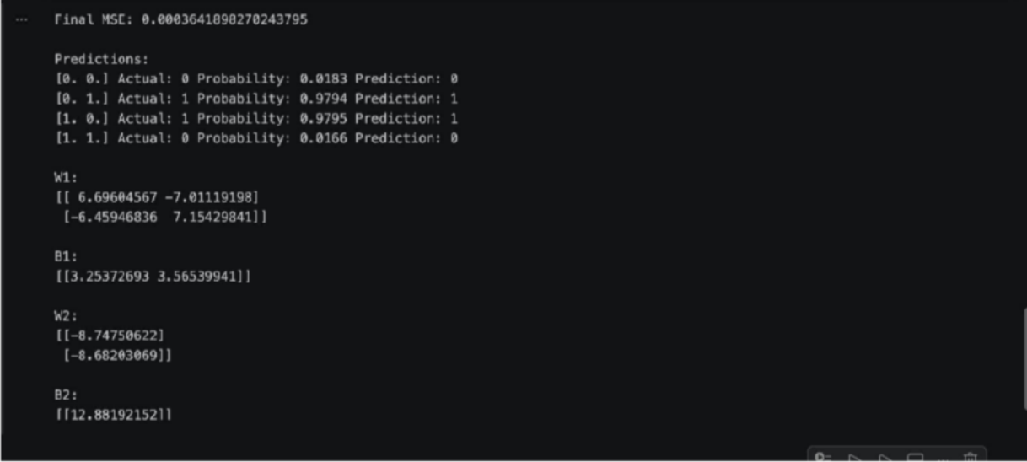
OUTPUT:
Trains the MLP on the XOR dataset and displays the final loss, predicted probabilities, predictions, weights, and biases.

Cell 4 — Loss Graph
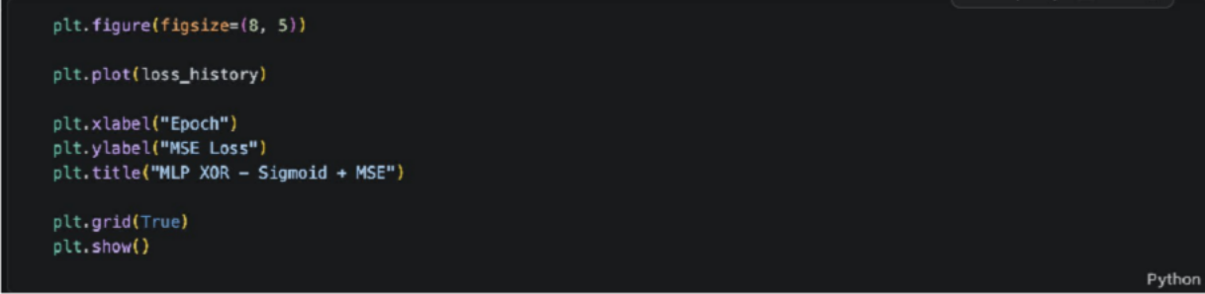

OUTPUT:

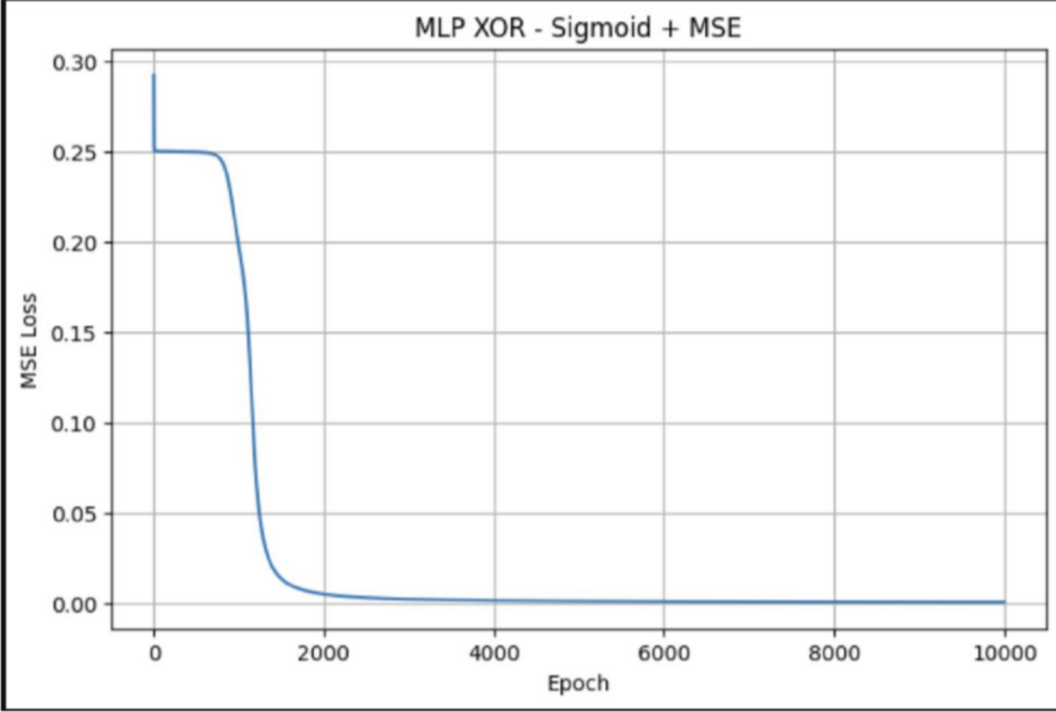
Plots the MSE loss across training epochs to show the convergence of the MLP. The MLP successfully learns the XOR relationship, demonstrating that a hidden layer enables the network to model non-linearly separable data.

Extensions.ipynb

Cell 1 — Extended MLP Class
import numpy as np
import matplotlib.pyplot as plt # XOR dataset
X = np.array([ [0, 0],
[0, 1],
[1, 0],
[1, 1]
], dtype=float) Y = np.array([
[0],
[1],
[1],
[0]
], dtype=float)
class ExtensionMLP: def _init_(
self, input_size=2, hidden_size=2, output_size=1, learning_rate=1.0,
activation="sigmoid", loss_function="mse", seed=42
):
self.learning_rate = learning_rate self.activation_name = activation self.loss_function = loss_function rng = np.random.default_rng(seed) self.W1 = rng.normal(
0,
0.5,
(input_size, hidden_size)
)
self.b1 = np.zeros( (1, hidden_size)

)
self.W2 = rng.normal( 0,
0.5,
(hidden_size, output_size)
)
self.b2 = np.zeros( (1, output_size)
)
#Sigmoid
def sigmoid(self, z):
z = np.clip(z, -500, 500)
return 1 / (1 + np.exp(-z)) # Hidden activation
def activation(self, z):
if self.activation_ame == "sigmoid": return self.sigmoid(z)
elif self.activation_name == "tanh": return np.tanh(z)
# Activation derivative
def activation_derivative(self, z, a):
if self.activation_name == "sigmoid": return a * (1 - a)
elif self.activation_name == "tanh": return 1 - a ** 2
#Forward propagation def forward(self, X):
self.Z1 = X @ self.W1 + self.b1 self.A1 = self.activation(self.Z1) self.Z2 = self.A1 @ self.W2 + self.b2 # Output uses sigmoid
self.Y_hat = self.sigmoid(self.Z2) return self.Y_hat
# Loss
def calculate_loss(self, Y, Y_hat): if self.loss_function == "mse":
return np.mean( (Y - Y_hat) ** 2
)
elif self.loss_function == "bce":

eps = 1e-12 Y_hat = np.clip(
Y_hat, eps,
1 - eps
)
return -np.mean(
Y * np.log(Y_hat)
+
(1 - Y) *
np.log(1 - Y_hat)) #Training
def train(self, X, Y, epochs=10000): loss_history = []
n = X.shape[0]
for epoch in range(epochs): # Forward
Y_hat = self.forward(X) # Loss
loss = self.calculate_loss( Y,
Y_hat
)
loss_history.append(loss) # Output delta
if self.loss_function == "mse": delta2 = (
(Y_hat - Y)
* Y_hat
* (1 - Y_hat)
)
elif self.loss_function == "bce": delta2 = Y_hat - Y
# Output gradients dW2 = (
self.A1.T @ delta2
) / n db2 = (
np.sum(
delta2,

axis=0, keepdims=True
) / n
)
# Hidden delta delta1 = (
delta2 @ self.W2.T
) * self.activation_derivative( self.Z1,
self.A1
)
# Hidden gradients dW1 = (
X.T @ delta1
) / n db1 = (
np.sum(
delta1, axis=0,
keepdims=True
) / n
)
# Parameter updates self.W2 - = (
self.learning_rate * dW2
)
self.b2 -= ( self.learning_rate * db2
)
self.W1 -= ( self.learning_rate * dW1
)
self.b1 -= ( self.learning_rate * db1
)
return loss_history # Prediction
def predict_probability(self, X): return self.forward(X)
def predict(self, X):

return (
self.predict_probability(X) >= 0.5
).astype(int)
Extends the MLP implementation to support different hidden-layer activation functions and loss functions, including Sigmoid, Tanh, MSE, and BCE.

Cell 2 — Tanh Activation
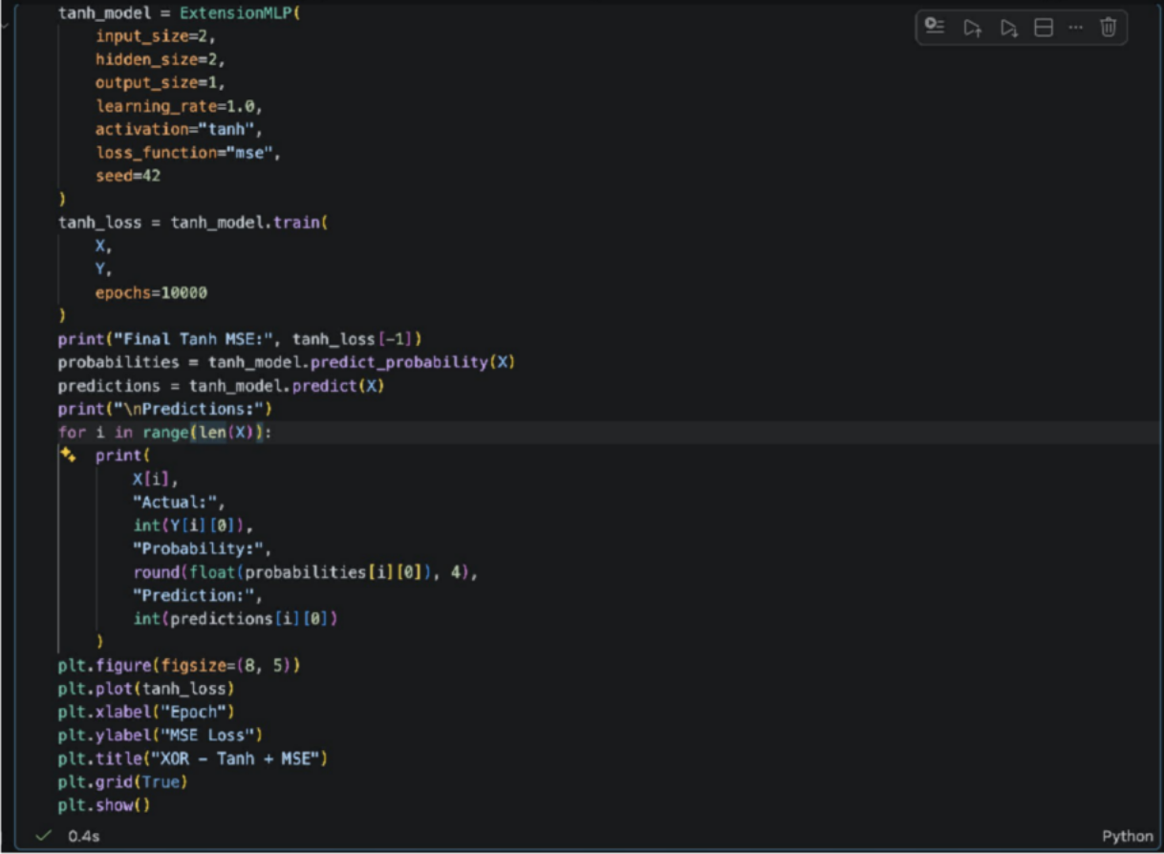

OUTPUT:

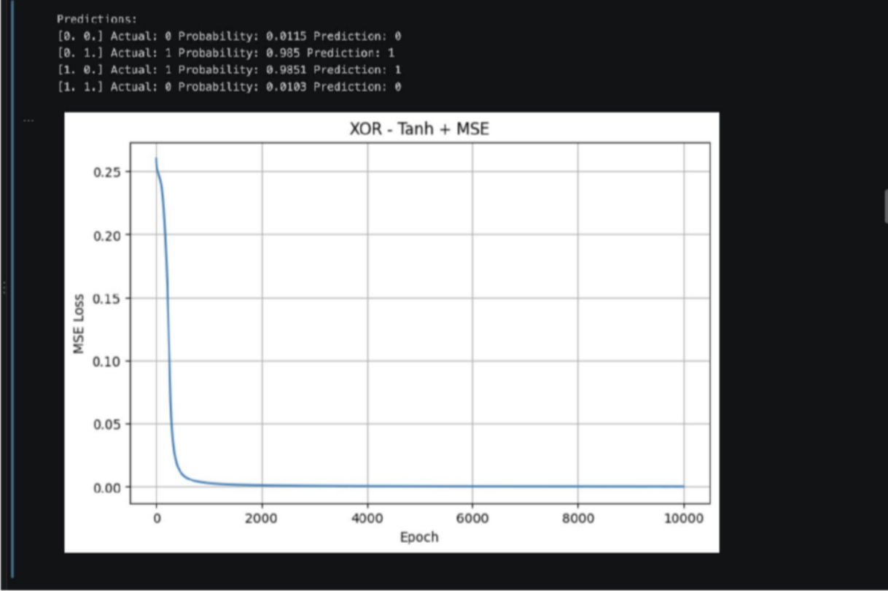
Trains the XOR model using Tanh activation in the hidden layer and evaluates its loss and predictions.
The Tanh-based MLP successfully learns the XOR pattern, showing that Tanh can also provide the non-linearity required for XOR.

Cell 3 — Binary Cross-Entropy
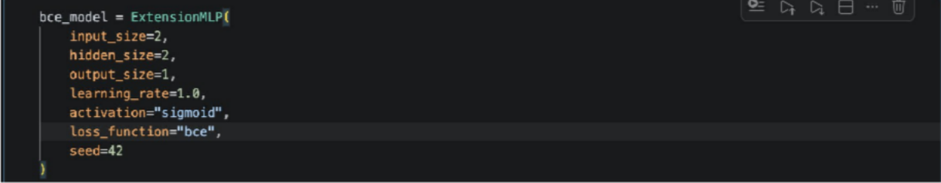

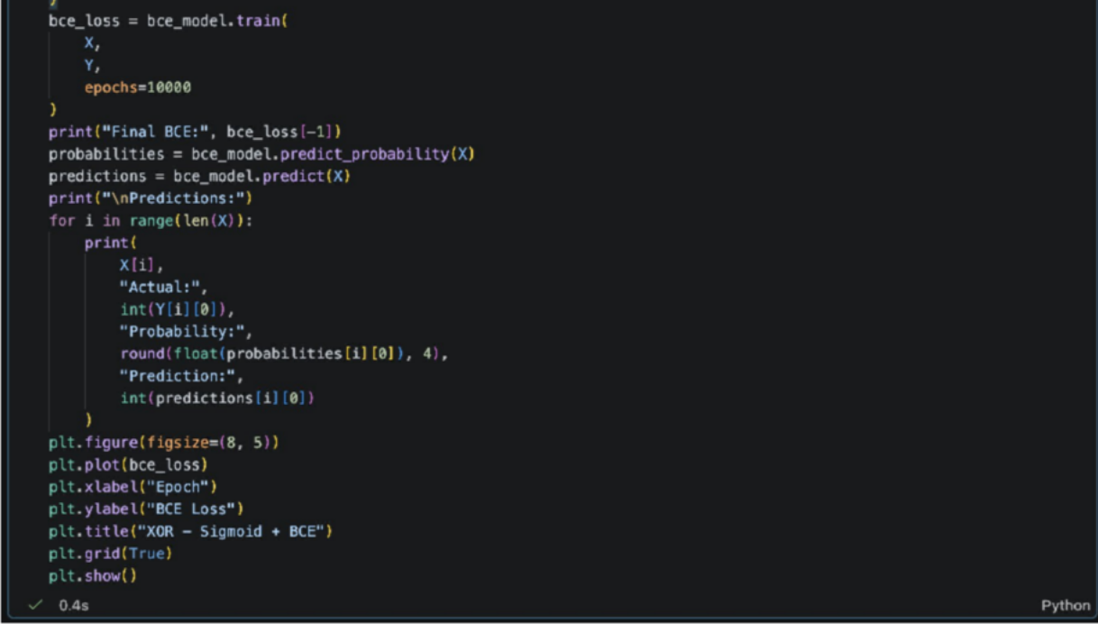
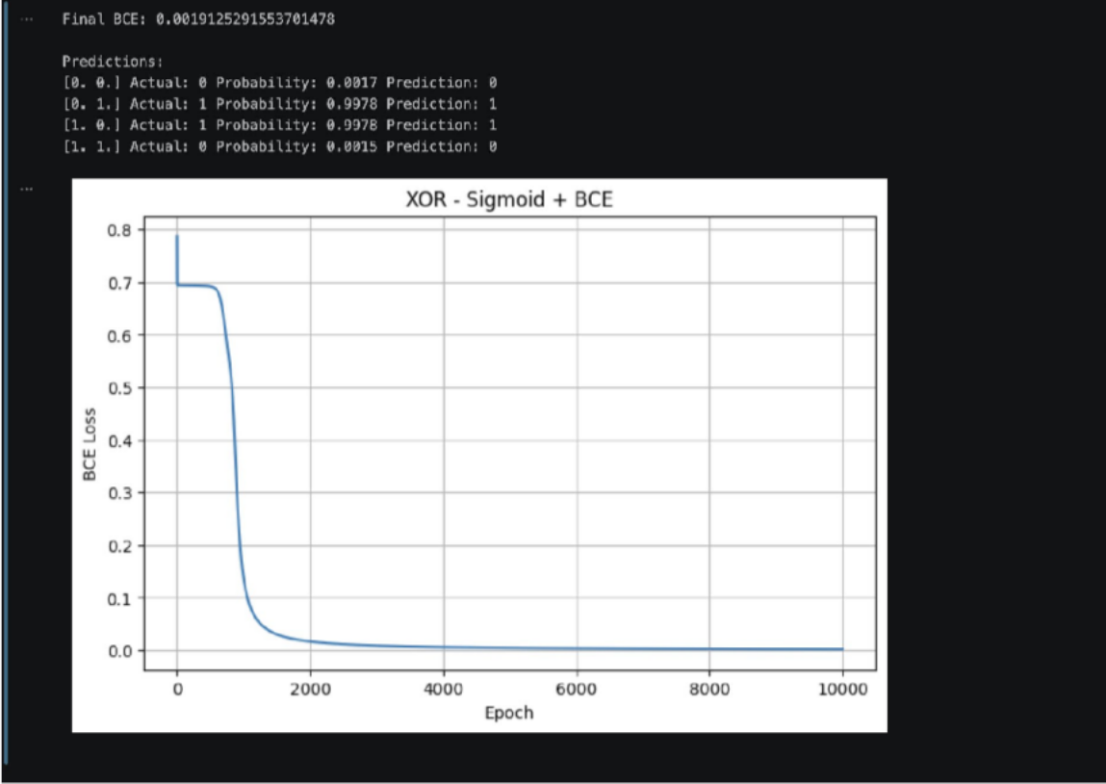
OUTPUT:

Trains the XOR model using Sigmoid activation with Binary Cross-Entropy loss and displays the resulting predictions and loss curve.

The BCE-based model learns the XOR classification and provides an alternative loss function for binary classification.

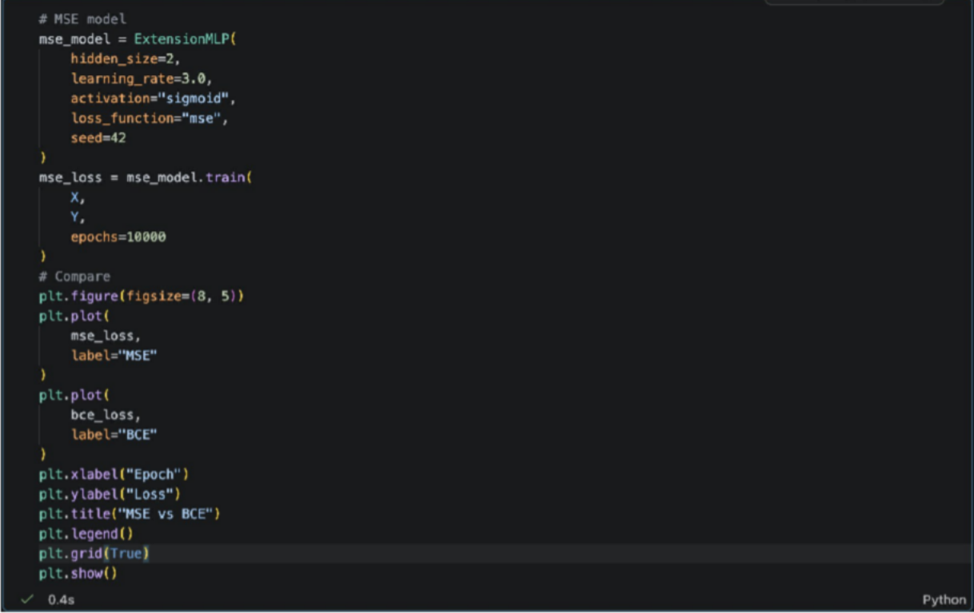
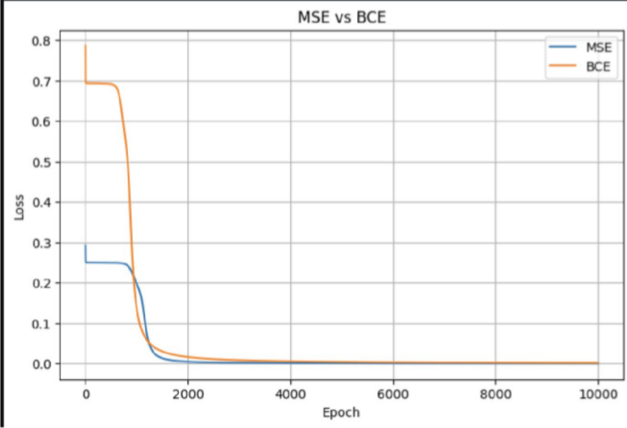
Cell 4 — MSE vs BCE

OUTPUT:
Compares the MSE and BCE loss curves to observe their training behavior on the XOR problem.

Both loss functions decrease during training, while BCE provides a classification-oriented loss for the sigmoid output.

Cell 5 — Hidden Neurons and Decision Boundaries
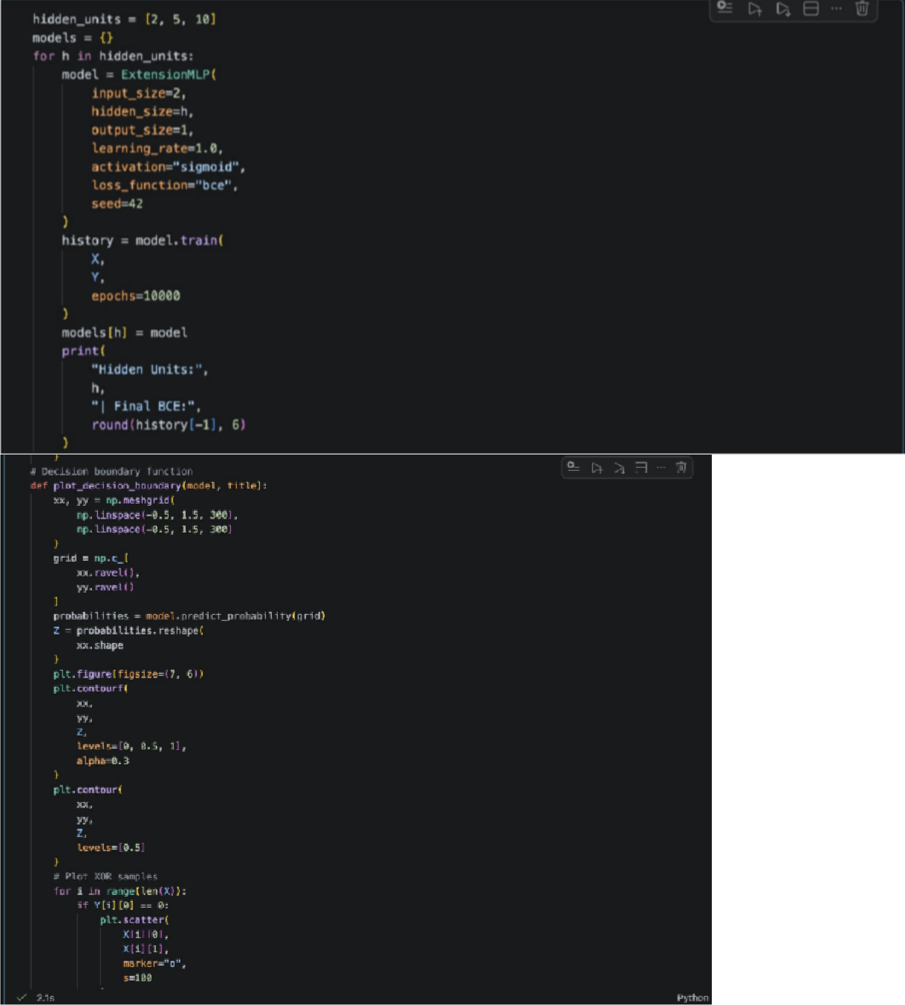

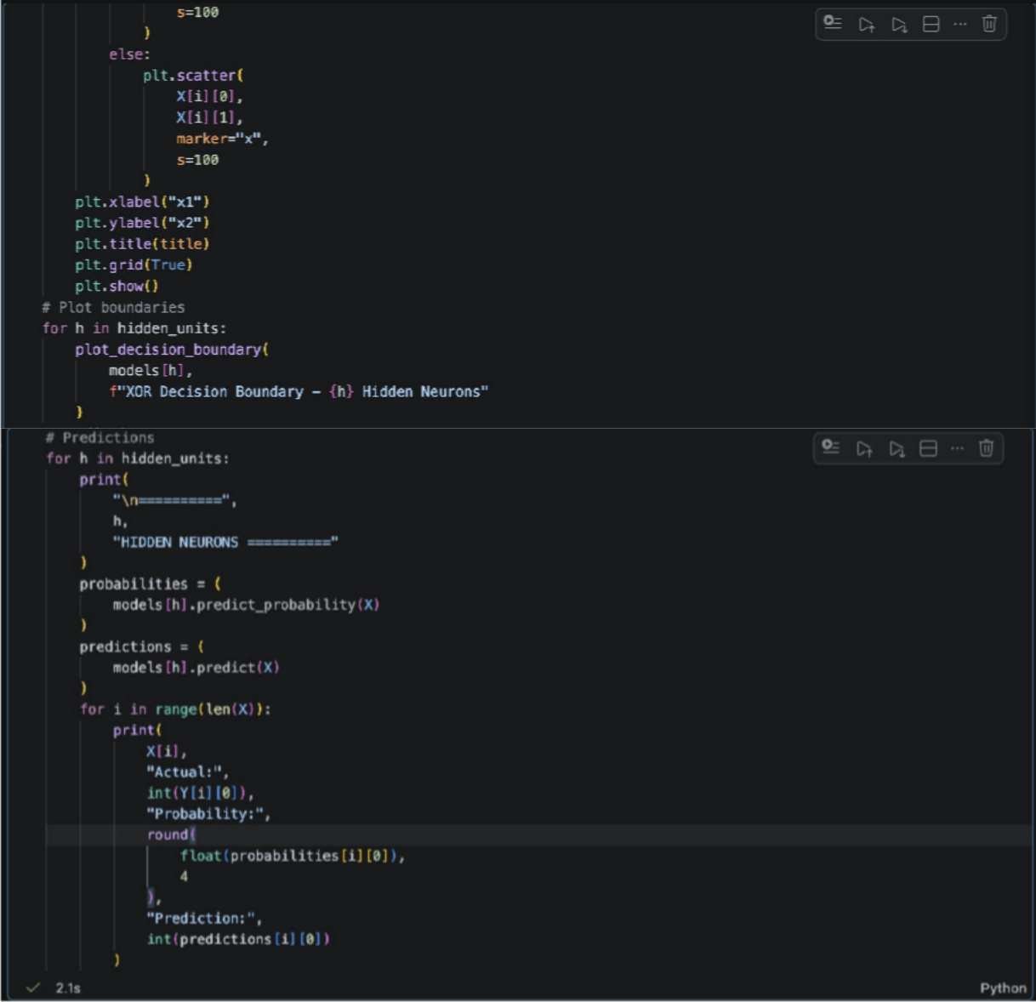

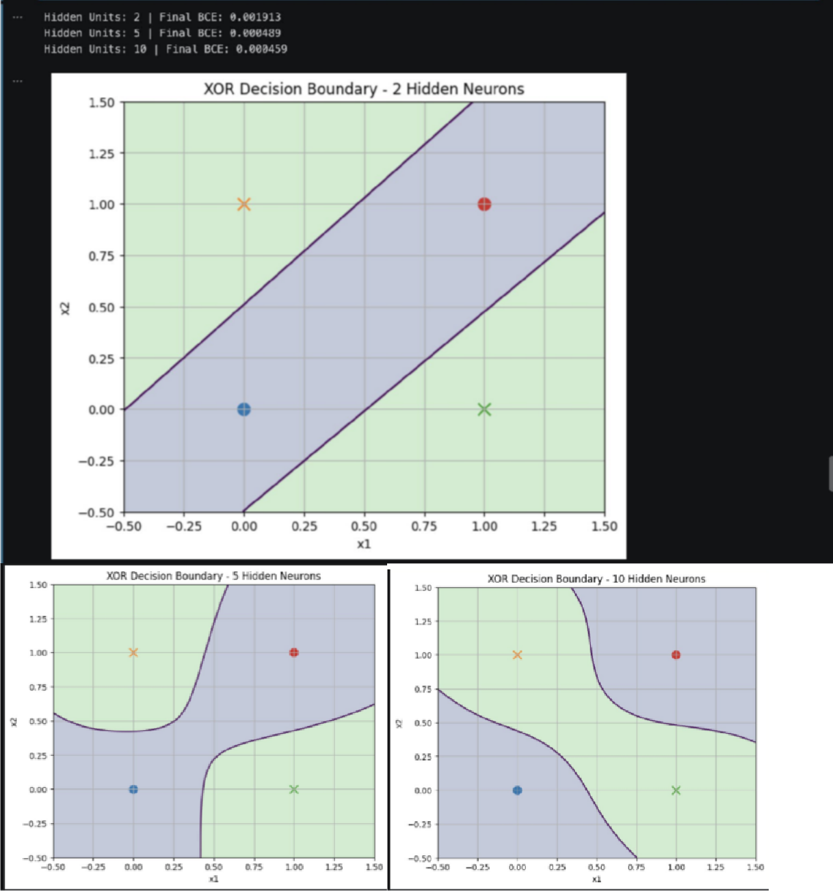
OUTPUT:

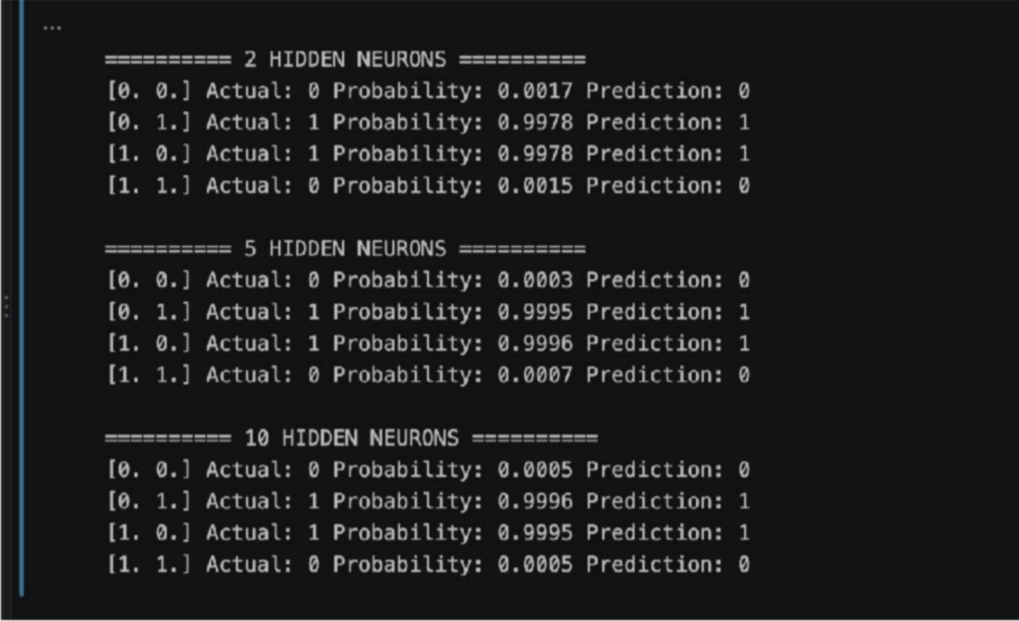
Trains MLPs with 2, 5, and 10 hidden neurons and visualizes their XOR decision boundaries and predictions.
Increasing the number of hidden neurons increases the network's capacity to represent complex decision boundaries, although XOR can already be solved with a small hidden layer.

Practical 8:
AIM: To implement seven optimization algorithms mathematically, calculate parameter updates over multiple iterations, and visualize their weight trajectories and update magnitudes.
Algorithm
- Initialize the weight, learning rate, momentum coefficients, and epsilon.
- Generate a decreasing gradient sequence.
- Initialize the internal state variables for the optimizers.
- Calculate the updated weight for each optimizer at every iteration.
- Store the weight values in separate lists.
- Calculate the absolute change in weight between consecutive iterations.
- Plot weight trajectories against iterations.
- Plot weight update magnitudes against iterations.
- Print and compare the final weights.

Code:
import numpy as np
import matplotlib.pyplot as plt
n = 20
eta = 0.1
beta1 = 0.9
beta2 = 0.9
beta2_adam = 0.999
decay = 0.01
eps = 1e-8
w0 = 10.0

grad = [1.0]
for i in range(1,n):
grad.append(max(0.1,grad[-1]-0.2))
nag_grad = [1.0]
for i in range(1,n):
nag_grad.append(max(0.05,nag_grad[-1]-0.2))

names = ["SGD","Momentum","NAG","AdaGrad","RMSProp","Adam","AdamW"]
weights = {name:[w0] for name in names}
vm,vn = 0.5,0.5
G,rms = 12.0,12.0
m,v = 0.5,12.0
for i in range(n):
g = grad[i]
w = weights["SGD"][-1]
weights["SGD"].append(w-eta*g)
vm = beta1*vm+g
weights["Momentum"].append(weights["Momentum"][-1]-eta*vm)
vn = beta1*vn+nag_grad[i]
weights["NAG"].append(weights["NAG"][-1]-eta*vn)
G += g**2
weights["AdaGrad"].append(weights["AdaGrad"][-1]-eta*g/(np.sqrt(G)+eps))
rms = beta2*rms+(1-beta2)*g**2

weights["RMSProp"].append(weights["RMSProp"][-1]-eta*g/(np.sqrt(rms)+eps))
m = beta1*m+(1-beta1)*g
v = beta2_adam*v+(1-beta2_adam)*g**2
adam_update = eta*m/(np.sqrt(v)+eps)
weights["Adam"].append(weights["Adam"][-1]-adam_update)
w = weights["AdamW"][-1]
weights["AdamW"].append(w-adam_update-eta*decay*w)

plt.figure(figsize=(10,5))
for name in names:
plt.plot(range(n+1),weights[name],marker="o",markersize=3,label=name)
plt.title("Weight Trajectories")
plt.xlabel("Iteration")
plt.ylabel("Weight Value")
plt.grid(True)
plt.legend()
plt.tight_layout()
plt.savefig("optimizer_weight_trajectories.png",dpi=300)
plt.show()

plt.figure(figsize=(10,5))
for name in names:
updates = np.abs(np.diff(weights[name]))
plt.plot(range(1,n+1),updates,marker="o",markersize=3,label=name)
plt.title("Weight Updates per Iteration")
plt.xlabel("Iteration")
plt.ylabel("Absolute Weight Change")
plt.grid(True)
plt.legend()
plt.tight_layout()
plt.savefig("optimizer_weight_updates.png",dpi=300)
plt.show()

print("Final weights:")
for name in names:
print(name,round(weights[name][-1],6))

OUTPUT:

Conclusion
The practical demonstrates that optimization algorithms follow different parameter-update trajectories. Momentum-based methods accumulate gradient information, while adaptive methods adjust update magnitudes using gradient statistics. AdamW additionally separates weight decay from the adaptive update.

Practical: 9
AIM: Empirical Evaluation and Visualization of Optimization Algorithms for Deep Convolutional Networks on CIFAR-10
An optimizer updates the trainable parameters of a neural network to minimize its loss function. Different optimizers use different strategies to determine the direction and size of parameter updates.
- SGD: Updates parameters using the current gradient and learning rate.
- Momentum: Uses previous gradients to accelerate convergence.
- NAG: Calculates the gradient at a look-ahead position to improve updates.
- AdaGrad: Adapts the learning rate using accumulated squared gradients.
- RMSProp: Uses an exponentially weighted average of squared gradients.
- Adam: Combines first- and second-moment estimates of gradients.
- AdamW: Uses decoupled weight decay to regularize model parameters.

CIFAR-10 contains 60,000 color images of size \(32 X 32), divided into 10 classes.
Training images: 50,000
Test images: 10,000
Number of classes: 10

Code:

OUTPUT:

Practical: 10

